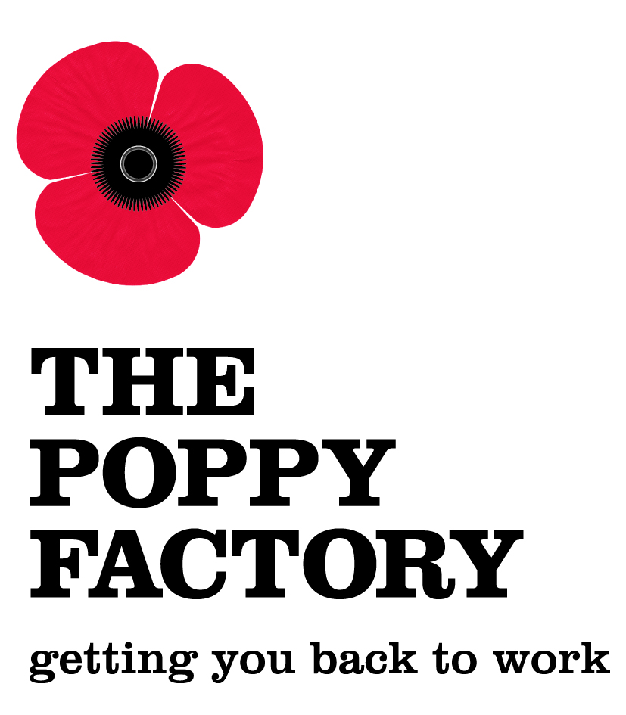
Head of Communications
Job Title: Head of Communications
Responsible to: Chief Executive
Responsible for: Communications, Insight and Marketing Functions
1 x Communications and Marketing Manager
1 x Insight Manager
1 x Communications and Marketing Assistant
Salary c£50-55k per annum
Position: Permanent, full time, 37.5 hours per week
Location The Poppy Factory, Richmond, Surrey

Role Purpose
- To develop and deliver a communications strategy that raises the profile of the Poppy Factory and supports the extension of its employability service to wounded, injured and sick (WIS) veterans.
- To lead the Poppy Factory’s strategic communications and evidence to key stakeholders the impact of its work to support WIS veterans into sustainable employment and to inspire stakeholders to engage and participate in this work.
- To be a member of the Poppy Factory’s senior leadership team and to contribute to its strategic planning and management function.
- To work in close partnership with the Head of Fundraising and Head of Employability Services to develop an integrated approach to fundraising, communications and marketing.
- To provide motivational leadership to the Communications, Insight and Marketing Function ensuring the development of a high performing team.
Key Responsibilities
Through the effective management of staff and resources, the Head of Communications will:
- Develop, manage and deliver the communications and marketing strategy, raise the Poppy Factory’s profile and extend its reach into key areas.
- Advise the Chief Executive, Trustees and senior leadership team on communications strategy and priorities.

- Oversee and be accountable for the production and management of all the Poppy Factory’s communications channels whether audio-visual, electronic or publications and materials.

- Ensure communications that are coherent and integrated across all the Poppy Factory activities and establish and reinforce a voice and brand recognised by different audiences.

- Take a lead role in defining the Poppy Factory brand, bringing greater awareness of our work and impact.

- Proactively lead media relations and PR activities for the Poppy Factory, acting as lead spokesperson and handling crisis and reputation management as required.

- Work collegiately with the Heads of Fundraising and Employability Services to deliver an integrated communications, fundraising and marketing strategy.

- Promote and support collective leadership, knowledge sharing and relationship building across the organisation and military charity sector.

- Contribute as a member of the senior leadership team to the strategic management of the Poppy Factory.

- Be responsible for the communications budget ensuring compliance with the Poppy Factory’s financial procedures.

- Deliver leadership and effective line management directly or through delegation via the management structure.

- Be responsible for development of the policy framework encompassing communications and related activities.

- Work flexibly to meet and support changes to the organisation/environment and undertake any other duties as required within the level and scope of the responsibilities of the role.

- To be an ambassador for the Poppy Factory, working in accordance with its vision, mission and values.
Person Specification – Head of Communications
Criteria | Essential | Desirable
Qualifications | - Educated to degree level with post graduate management or media related qualification or equivalent experience  - Evidence of continuous professional development
Experience | - Significant experience of developing and delivering communications strategy  - Significant experience in brand management, marketing and marketing strategies  - Demonstrable experience of working at a strategic level and as an integral part of a senior leadership team  - Experience of influencing high-level audiences, both internal and external  - Proven experience of strategic thinking  - Proven experience of leading a team to work in a creative and collaborative fashion to achieve required outputs  - Significant experience of managing teams and projects, delivering on time and on budget  - Demonstrable experience of being an opinion former in a specialised sector  - Experience of leading and managing within a context of organisation change | Experience gained within the charity or not for profit sector  Experience of the military
Knowledge & Skills | - Knowledge and experience of handling the media including print, broadcast and social media  - Confident in a wide range of communications channels and modern and emergent communications and marketing techniques  - Confident in strategic planning, leadership and people management, budget management and decision making  - Excellent presentation skills in public and with the media and able to represent the Poppy Factory at a high level  - Excellent communication and interpersonal skills  - Creative thinker with strong analytical skills able to assimilate information quickly  - Political awareness  - Able to work effectively under pressure and dealing with conflicting priorities  - Extensive knowledge of Microsoft Office programmes, current web technologies and the print production process  - Excellent project management skills | Knowledge of public policy in the field of disability and employment
Personal Attributes | - Resilient and tenacious in approach to challenges  - Comfortable working in a diverse environment  - Self-starter, strives to achieve excellent results  - Open to new ideas and perspectives  - Empathy with needs of the Poppy Factory’s client group  - Acts as a role model and leads by example

Head of Communications – February 2017

