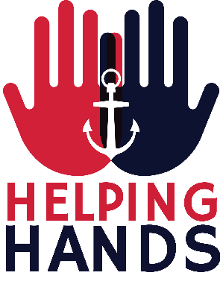
Criteria: The Royal Navy and Royal Marines (RNRMC)
Helping Hands Grant programme (Promoting volunteering) 2017

The RNRMC held a workshop to consult with a wide range of charity partners to explore the needs of beneficiaries a presented to frontline organisations. The workshop findings and military research has directly informed the development of the outcomes to meet their need. This programme seeks to address the key outcomes by grants to organisations who will recruit and supervise volunteers to support beneficiaries.

Beneficiary group | Key Outcomes | How could this be delivered?  Outputs  services to be provided (some examples)
Veterans  (Former- Serving) | - To combat loneliness and social isolation  - To promote health and well-being  - To prevent escalation of need or deterioration in health  - To enable people to remain independent for as long as possible  - To support end of life care | - Fellowship and support, home visiting and group support  - Information and signposting  - Advocacy support  - Dementia support  - Benefits and money advice  - Building community support networks  - Activities in residential care  - Relationship support
Serving | - To maintain family relationships  - To support the transition to civilian life  - To maintain social networks and a link to service life  - To manage budgets and personnel administration | - Relationship support  - Employment support, mentor, coaching support  - Fellowship, link to military associations  - Budgets skills. Debt advice
Children and Families | - To provide support for families to improve outcomes for children young people and their families  - To provide support for families during deployment  - To provide support for families who need extra support with children with health, social care or education needs | - Relationship support  - Practical help with children  - activities during deployment, home visits  - Respite care  - Short term breaks  - Activities to support special needs  - Family events
All beneficiary Groups | - To improve the quality of life for beneficiaries  - To support good mental health and improved sense of health and wellbeing  - To combat debt and promote financial stability  - To provide signposting to information and resources  - To provide support for carers  - To provide information and support | - Programmes that support the treatment and support of PTSD  - Programmes that support addiction recovery  - Information and advice services  - Signposting/ information and advice  - Housing support  - Money and debt advice  - Fellowship and advice – community networks  - Peer support and befriending  - Brokerage  - Developing circles of support  - Dementia Support
We would not wish you to spend time developing an application with little chance of success so please consider the above fund outcomes carefully. What we are unlikely to fund:
- Where a project only benefits one person
- Organisational fundraising activities
- Retrospective funding for projects that have already taken place
- Memorials
- Trading ventures
- Capital expenditure ( except where it is a contribution to a larger project or for a small capital item)
- Research

