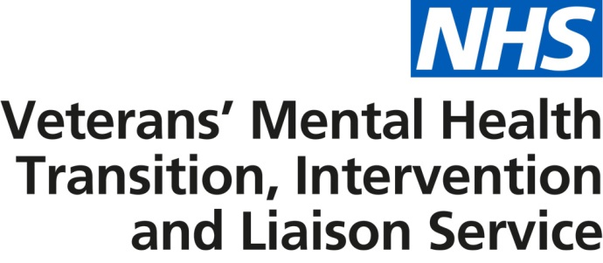

Articles and tweets to support promotion of the veterans’ mental health transition, intervention and liaison service

News letter / web copy – short version

Improving mental health services for veterans and armed forces personnel approaching discharge
NHS England has launched improved mental health services for veterans in response to a national engagement undertaken last year. The service builds on the success of current provision and seeks to provide increased access and treatment in a more uniformed manner that is sensitive to the needs of patients and their families. A significant benefit of the new service is that armed forces personnel approaching discharge can also now access NHS care and treatment for mental health conditions. Available across England, patients are able to self-refer or request referral via a health care professional or service charity, regardless of when they left the armed forces. To find out more visit here.

News letter / web copy – long version

Improving mental health services for veterans and armed forces personnel approaching discharge
NHS England has launched improved mental health services for veterans in response to a national engagement undertaken last year. The views of veterans and their families have helped to inform a service that builds on the success of previous provision and seeks to provide increased access to local care and treatment across the country in a more uniformed manner. This includes recognising the early signs of mental health problems and providing access to early treatment and support, as well as therapeutic treatment for complex mental health difficulties and psychological trauma. Patients are also provided with help, where appropriate, with employment, reduction in alcohol consumption, housing and social support.

Available across England, the service works closely with the wider NHS, local authorities and third sector organisations to ensure the appropriate care is in place for patients and their families.

A significant benefit of the new service is that armed forces personnel approaching discharge can also now access NHS care and treatment for mental health conditions and thereafter into civilian life regardless of when they leave the military. Patients are able to self-refer or request referral via a health care professional or service charity, such as Combat Stress, the Royal British Legion and Help for Heroes.

To find out more visit here.

Suggested tweets

Improved #NHS #veterans #mentalhealth service now available http://ow.ly/7w7S30avafp. Watch the @Forces_TV interview http://ow.ly/IbD330avanp

#ArmedForces personnel due to leave the #military can now access #NHS #veterans #mentalhealth services in England http://ow.ly/7w7S30avafp

Thanks to all who helped shape the new #NHS #veterans #mentalhealth service http://ow.ly/7w7S30avafp

Watch the @Forces_TV interview on the #NHS #veterans #mentalhealth service http://ow.ly/IbD330avanp

New #veterans #mentalhealth service announced by @NHSEngland (http://ow.ly/WtNm30avaqL). Now available to those due to leave the #ArmedForces

