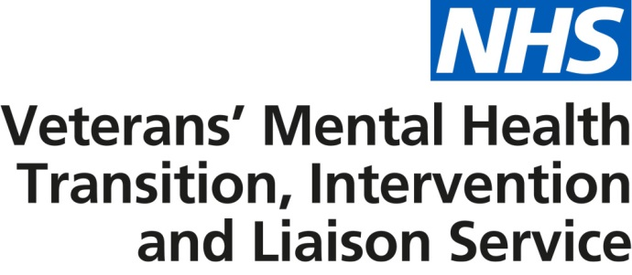

PRESS RELEASE

Next steps on the NHS Five Year Forward View: 17,500 forces veterans and service personnel to benefit from £9m investment in new and improved NHS mental health services

NHS England has launched a brand new mental health service which has been specially tailored to support and treat ex-armed forces veterans and service personnel who are approaching discharge.

The newly commissioned £9m service, known officially as the NHS transition, intervention and liaison (TIL) veterans’ mental health service, will act as a front door to a range of mental health services across the health and care system for 17,500 people over the next three years.

Different levels of specialist treatment, support and healthcare experts will be available and on hand - ensuring those who proudly serve and put their lives on the line for their country, get the care they deserve, as quickly as possible - all of the time.

Available across England, service personnel approaching discharge and veterans will be able to either self-refer or request referral via their GP or mental health provider or through a military charity like Combat Stress, the Royal British Legion, Help for Heroes and SSAFA. An initial face to face assessment will be offered within a fortnight and where appropriate, a clinical appointment two weeks later.

The service has been designed to help recognise some of the early signs associated with mental health difficulties and will provide access to a number of interventions, therapeutic treatments for complex problems and psychological trauma and prevent patients reaching crisis point.

It will also help tackle some of the most common mental health issues such as alcoholism, anxiety and depression and join up services across the board, working with local authorities and charities, so that the whole of a person’s needs and their families, are looked after. This might also include help and support on practical issues such as housing after discharge, as well as quick access to social care where necessary and an out of hours contact in the event of an emergency.

NHS England asked veterans, serving personnel and their families for views on what they would like to see within the new service and what it could do to build on the current provisions already available. The aim is to not only improve mental health and wellbeing but also ensure a smooth transition from armed forces healthcare to the NHS and civilian life.

Matt Stoodley, an ex Falklands Veteran and user of NHS veterans’ mental health services, said: “Having used the NHS South Central Veterans’ Mental Health Service which TIL replaces, I cannot stress enough the importance of the NHS and military charities, without which the plight of veterans’ mental health would go undiagnosed and not be treated correctly. After being diagnosed with PTSD, I attended a course under the incredible guiding hand of Dr Mark Bruce, which for me lasted close to 19 months. I have and will continue my support for this programme.”

Dr Jonathan Leach, Chair of NHS England’s Armed Forces and their Families Clinical Reference Group, said: "Whilst both as a military doctor and then as an NHS GP I have seen patients who require quick access to care and the new service will allow that. A key part of the new system is helping patients to get access to the right care, as well as providing a specific service for veterans where an understanding of the military culture and what some patients may have been through, would allow them to get better and get better quicker.

“The new service has been designed following a lot of work where we have looked in detail at the needs of patients, as well as listened to their views and concerns. I am hoping that the new system will make a big difference to the health and wellbeing of veterans and also have a positive impact upon their families and those around them.”

Surgeon Commodore Paul Hughes QHP FRCGP Commander of Defence Primary Healthcare for the Ministry of Defence, said: “I am delighted to see the launch of this service which is a result of the MOD working in close partnership with NHS England. It will provide seamless mental health care for service personnel in the last months of service and beyond as they transition into civilian life. This will make a real difference by ensuring that our personnel continue to receive the level of care that they both need and deserve.”

The three main elements of the service are as follows:

- Transition (service for those leaving the armed forces): Feedback from veterans and their families highlighted more should be done to support a smoother transaction from the armed forces to the NHS. The new service will work with the MOD to offer mental health support for armed forces personnel before their discharge date.
- Intervention (service for veterans with complex mental health issues): Service personnel approaching discharge and veterans will have an assessment within 14 days of referral. Depending on their individual needs, they will be offered a clinical appointment. They will be treated by a clinician with an expert understanding of armed forces life and culture. They may also be supported by a care coordinator who will work with other services and organisations and act as a single point of contact, to ensure a coordinated approach to their care.
- Liaison (general service for veterans): Patients, who do not have any complex presentations, but might benefit from mainstream services, will be referred into local NHS mental health services where they will receive treatment and support.
ENDS

Notes to editor

- The TIL veterans’ mental health service comes after a national questionnaire to gain feedback about service provision prior to 1 April 2017.
- The service has been awarded £9m in total, with £3m per year spread over the course of three year contract.
- Many veterans requiring support for mental health difficulties use mainstream mental health services, which are expanding significantly through the national Improving Access to Psychological Therapies (IAPT) programme and over 20,000 per year are already using these services and getting outcomes at least as good as those of the general population.
- The TIL veterans’ mental health service will work closely with all pathways in NHS services including primary care and our partners in the armed forces charitable and independent sector.
- The TIL veterans’ mental health service will provide local care and treatment in a range of locations and settings and via different methods, such as Skype.
- The service providers will support delivery of the Five Year Forward View for Mental Health through partnership working with local public, private and voluntary sector organisations, recognising the contributions of each to improving mental health wellbeing.
- Following the procurement of a three year contract, NHS England has appointed the following providers to provide care across England: Avon and Wiltshire Mental Health Partnership NHS Trust (Buckinghamshire, Oxfordshire, Berkshire, Hampshire, Isle of Wight and the South West of England) Camden and Islington NHS Foundation Trust (South East of England and London) Coventry and Warwickshire Partnership NHS Trust (Midlands and East of England) Northumberland, Tyne and Wear NHS Foundation Trust (North of England).

ENDS

