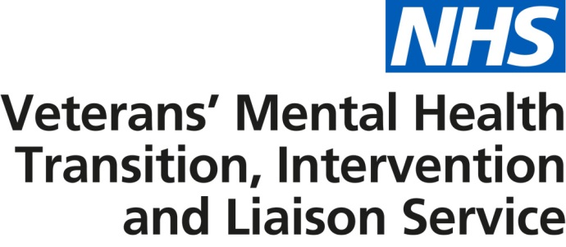

Improved NHS veterans’ mental health services now available across England

Information for patients

Improved NHS veterans’ mental health services are now available across England.

If you are experiencing mental health difficulties, these services can provide a range of treatment and support regardless of when you left the armed forces. This includes recognising the early signs of mental health problems and providing access to early treatment and support, as well as therapeutic treatment for complex mental health difficulties and psychological trauma. Patients are also provided with help, where appropriate, with employment, reduction in alcohol consumption, housing and social support.

To access these services, you must meet the following criteria:

- be a resident in England
- have served in the UK armed forces for a full day
- be registered with a GP practice in England or be willing to register with a GP
- be able to provide your military service number or another form of acceptable proof of eligibility.

If you meet these criteria, you can self-refer or request referral via a health care professional or service charity.

Upon receipt of referral, you will be offered an initial face to face assessment within two weeks and where appropriate a first clinical appointment two weeks thereafter.

Do you need help?
To find out more, speak to a health care professional or service charity or use the contact details below to get in contact with your local service.

North of England
(County Durham, North Yorkshire, Northumberland, Tyne and Wear, Cheshire, Cumbria, Greater Manchester, Lancashire, Merseyside, East Riding of Yorkshire, Lincolnshire, North Yorkshire, South Yorkshire and West Yorkshire)
Service contact | Email | Contact number
Anna Burke | vwals@nhs.net | 0191 441 5974

Midlands and East of England
(Herefordshire, Shropshire, Staffordshire, Warwickshire, West Midlands, Worcestershire, Bedfordshire, Cambridgeshire, Essex, Hertfordshire, Norfolk and Suffolk)
Service contact | Email | Contact number
Diane Palmer | mevs@mhm.org.uk | 0300 323 0137

London and South East England
(Greater London, Kent, Surrey, East Sussex and West Sussex)
Service contact | Email | Contact number
Sue Ferrier | cim-tr.veteranstilservice-lse@nhs.net | 020 3317 6818

South Central and South West England
(Buckinghamshire, Oxfordshire, Berkshire, Hampshire, Isle of Wight, Wiltshire, Gloucestershire, Bristol, Devon, Dorset, Somerset, Cornwall and Isles of Scilly)
Service contact | Email | Contact number
David Wilcox  (Gloucestershire, Bristol, Devon, Dorset, Somerset, Cornwall and Isles of Scilly) | awp.swveterans@nhs.net | 0300 365 0300
Adele Stevens  (Buckinghamshire, Oxfordshire, Berkshire, Hampshire and the Isle of Wight) | sc.veterans@nhs.net

Further information
Information on the service can be found on NHS Choices.

