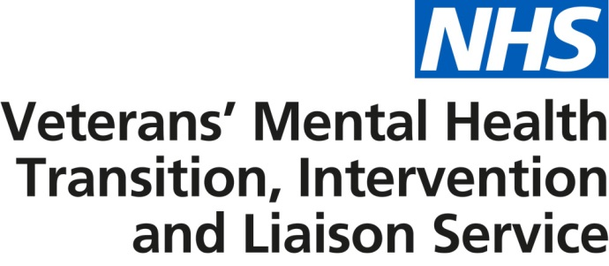

Transition, intervention and liaison mental health service for armed forces personnel approaching discharge and veterans

Information for referrers

Improved NHS veterans’ mental health services are now available across England.

These services provide a range of treatment and support for veterans, as well as armed forces personnel approaching discharge. This includes recognising the early signs of mental health problems and providing access to early treatment and support, as well as therapeutic treatment for complex mental health difficulties and psychological trauma. Patients are also provided with help, where appropriate, with employment, reduction in alcohol consumption, housing and social support.

Known as the transition, intervention and liaison (TIL) veterans’ mental health service, the following providers have been appointed to deliver it under a three year contract:

- Avon and Wiltshire Mental Health Partnership NHS Trust (covering Buckinghamshire, Oxfordshire, Berkshire, Hampshire, Isle of Wight and the South West of England)
- Camden and Islington NHS Foundation Trust (covering South East of England and London)
- Coventry and Warwickshire Partnership NHS Trust (covering the Midlands and East of England)
- Northumberland, Tyne and Wear NHS Foundation Trust (covering the North of England).

The service seeks to increase access and treatment to appropriate and timely mental health services for armed forces personnel approaching discharge and veterans with mental health difficulties. There are three elements to the service:

- Transition: service for those in transition, leaving the armed forces
The service will work with the Ministry of Defence (MOD) to offer mental health support for armed forces personnel approaching discharge.
- Intervention: service for veterans with complex presentation
Service personnel approaching discharge and veterans will have an assessment within two weeks of a receipt of referral. If their needs are identified as more complex, they will be offered an appointment two weeks thereafter at the TIL veterans’ mental health service. This will be with a clinician who has an expert understanding of armed forces life and culture. They may also be supported by a care coordinator who will liaise with other services and organisations to ensure a coordinated approach to their care.
- Liaison: general service for veterans
Patients who do not have complex presentations, yet would benefit from NHS care, will be referred into local mainstream NHS mental health services where they will receive treatment and support.

Patient centred care
Launched on 1 April 2017, the new service offers the following:

- A national service that seeks to provide increased access to local care and treatment across England in a more uniformed manner.
- Veterans, and for the first time armed forces personnel approaching discharge, can self-refer or request referral via a health care professional or service charity, with an initial face to face assessment offered within two weeks of a receipt of referral and where appropriate a first clinical appointment offered two weeks thereafter.
- Veterans can access the service regardless of when they leave the armed forces.
- A single point of contact for patients that accepts and makes referrals so that the appropriate care and support is accessed in a timely and responsive manner.
- An enhanced range of treatment and support provided from recognising the early signs of mental health problems and providing access to early interventions, to providing therapeutic treatment for complex mental health difficulties and psychological trauma.
- Patient advice and care provided in a range of locations and settings and via a range of methods, such as face to face and Skype, to support improved access.
- A Care Programme Approach, with patients involved in the development of tailored care packages to help them enjoy a full life and achieve positive outcomes relating to mental health, employment and reduction in alcohol consumption, as well as improved housing and social support.

- Where appropriate, families and carers will be involved in planning and assessing care with patients and will be supported to access care and treatment for themselves if required.
- All patients being seen in the service will have access to an out of hours point of contact in the event of an emergency.
- Collaborative working with the wider NHS, Defence Medical Services (DMS), statutory bodies, local authorities and the third sector to ensure holistic support is in place for patients and their families. This will also include working with existing veterans’ mental health services commissioned by NHS clinical commissioning groups so that patients can access and receive the highest quality of service.

- A single point of contact over extended working hours for health and social care professionals that provides evidenced based professional advice on the treatment of and support for veterans with acute mental health difficulties and guides providers on the most appropriate initial treatments, including referral pathways.

Access criteria
To access the service as a veteran, patients must:

- be a resident in England
- have served in the UK armed forces for a full day
- be registered with a GP practice in England or be willing to register with a GP
- be able to provide their military service number or another form of acceptable proof of eligibility.

Those people meeting the criteria can self-refer or request referral via a health care professional or service charity.

Further information
Information on the service can be found on the NHS Choices and NHS England websites.

If you have any queries, please email england.south-armedforces@nhs.net

Service information
The four providers will each cover a separate region in England as shown below.

North of England
(County Durham, North Yorkshire, Northumberland, Tyne and Wear, Cheshire, Cumbria, Greater Manchester, Lancashire, Merseyside, East Riding of Yorkshire, North Lincolnshire, North Yorkshire, South Yorkshire and West Yorkshire)
Service contact | Email | Contact number
Anna Burke | vwals@nhs.net | 0191 441 5974

Midlands and East of England
(Derbyshire, Leicestershire, Lincolnshire, Northamptonshire, Nottinghamshire, Rutland, Herefordshire, Shropshire, Staffordshire, Warwickshire, West Midlands, Worcestershire, Bedfordshire, Cambridgeshire, Essex, Hertfordshire, Norfolk and Suffolk)
Service contact | Email | Contact number
Diane Palmer | mevs@mhm.org.uk | 0300 323 0137

London and South East England
(Greater London, Kent, Surrey, East Sussex and West Sussex)
Service contact | Email | Contact number
Sue Ferrier | cim-tr.veteranstilservice-lse@nhs.net | 020 3317 6818

South Central and South West England
(Buckinghamshire, Oxfordshire, Berkshire, Hampshire, Isle of Wight, Wiltshire, Gloucestershire, Bristol, Devon, Dorset, Somerset, Cornwall and Isles of Scilly)
Service contact | Email | Contact number
David Wilcox  (Gloucestershire, Bristol, Devon, Dorset, Somerset, Cornwall and Isles of Scilly) | awp.swveterans@nhs.net | 0300 365 0300
Adele Stevens  (Buckinghamshire, Oxfordshire, Berkshire, Hampshire and the Isle of Wight) | sc.veterans@nhs.net

