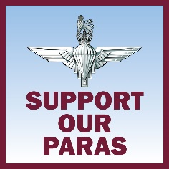

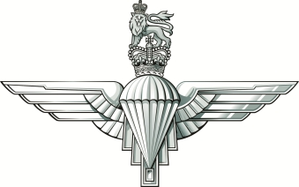

# Data and IT Manager

# (Regimental Communications Cell)

**Application Process**

* **Please send a copy of your Curriculum Vitae to the Regimental Secretary at the address below by**

**Friday 8 December 2017**

* **Interviews will take place on. Thursday 14 December 2017**

**An opportunity has arisen within the Headquarters of The Parachute Regiment for a Data and IT Manager.**

The successful applicant will work in a small team providing the IT and Data Protection coordination and support function to RHQ PARA. The candidate will have proven experience in IT and Data administration and be a self-starter who is capable of working with limited supervision to provide support to a busy Regimental Communications Cell. Previous experience of working in the IT sector would be beneficial. The appointee will be employed by the Parachute Regiment Charitiy and should have excellent interpersonal and IT skills and be competent in all forms of communication.

The three key tasks of the Data and IT Manager are:

a. Maintenance of all websites supporting The Parachute Regiment Charities, the Airborne Network website, incorporating a content management system and maintenance of and all RHQ servers.

b. Assist the RHQ Data Protection Officer to implement requirements of the general Data Protection Regulation for RHQ PARA, the Regimental Charities, Museum and Association.

c. Assist the Communications Officer with the installation of the Subscriber Customer Relationship Manager (SCRM) a data management system.

The routine tasks include:

a. Maintaining PRC web servers and liaising with service provider.

b. Routine backup of email and website data.

c. Maintaining data as per GDPR.

d. Managing security of web/mail servers and the data they contain.

e. Providing technical support to RHQ staff.

**Location -** Merville Barracks, Colchester CO2 7UT.

**Travel -** There will be a requirement to attend conferences and meetings in London and elsewhere as the need arises; therefore a current driving license is essential. Some overnight stays are required. Accommodation, subsistence and travel will be provided at Civil Service equivalent rates.

**Salary –­** The salary on offer is £22,500 per annum.

**Contract** – an initial fixed 1 year contract subject to review.

**Hours** **–** 40 per week – Core Hours 08:30-16:30.

**Overtime** **–** Overtime paid as time off in lieu.

Further information on the Regiment and its Benevolence Policy can be found at: www.parawelfare.org

­

### Regimental Headquarters

**The Parachute Regiment**

**Merville Barracks**

**Circular Road South**

**Colchester**

**Essex**

**CO2 7UT**

**Phone: 01206 817072**

**E-mail paul.rodgers694@mod.gov.uk**