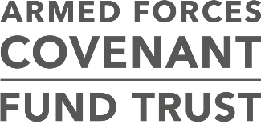

Consultation on the new ways to tackle Serious Stress in Veterans, Carers and Families Programme

Briefing

The Armed Forces Covenant Fund Trust has launched a consultation to help shape a new £4 million programme designed to providing funding for innovative and new ways of
working to reduce serious stress in veterans, their carers and families.

The consultation will explore how the programme should be delivered and the types of projects that should be funded. They are keen to hear from anyone with a view, but it is particularly relevant to veterans, charities with an interest in the Armed Forces Community, charities with an interest in mental health or health bodies.

The intention of this programme is to fund a small number of projects that will enable charities and health professionals to work together to develop and try new ideas that they have developed with veterans and their carers and families. The programme will support projects where there is good evidence to suggest that the idea might produce outcomes that are better than current sources of support on offer.

It will make grants to try new ways of working that are on top of existing services, filling gaps in statutory provision and making a genuine and lasting difference to those in significant need, while not overlapping with any of the existing veterans’ mental health services.
The programme will target veterans with severe mental health needs, and will explore how carers and families can be supported.

The aim of the programme are to make a long-term difference by being able to show how the best ideas improve care for veterans and their families. An overarching support and research project will evaluate awarded grants; and the Trust is keen to explore how the most successful projects can be supported to continue.

The consultation will run until 19th June 2018. The programme will open for applications in September 2018. Grants will be awarded in February 2019.

For further details on the consultation, please visit: www.covenantfund.org.uk. A background briefing paper and consultation summary document is available.

