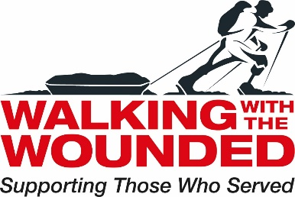

Job Description

Job Title Portfolio Manager (North England Care Coordination Partnership: new ways to tackle serious stress in veterans, their carers and families)

Reports to Operations Manager North East

Based at Gateshead WWTW Hub, with regular travel to NHS TILS / CTS sites and WWTW Manchester Hub

Job Purpose | To oversee all aspects the new North England Care Coordination partnership: new ways to tackle serious stress in veterans, their carers and families Programme, from its development to implementing program activities.  To ensure the programme is completed to a consistently high standard, within budget and that objectives are met on time. To ensure that the programme meets WWTW professional standards and the reporting requirements.

Primary Responsibilities | - To coordinate the programme across the two delivery locations of Manchester and Gateshead  - To facilitate the embedding of the programme team into the veteran Transition, Intervention and Liaison service team (TILS) and Complex Treatment Service (CTS)  - Develop and maintain relationships with the key partner organisations in each location  - Establish short and long-term program objectives and ensures team members meet them  - Recruit, hire, and train team members  - Develop the budget and schedule monthly budget reporting throughout the program's implementation to ensure we are on track  - Ensuring all reporting requirements are met  - Assign tasks to team members to ensure project objectives are completed as required  - Communicate expectations to team members  - Counsel and discipline team members who do not perform to expectations or who violate company policies  - Appraise team members' performances and offer feedback to employees and, when appropriate, to managers  - Resolve problems within programme as they arise  - Develop and implement the programmes exit strategy  - To ensure that the programme meets WWTW professional standards and the reporting requirements  - To be based in Gateshead three days per week and in Manchester two dates per week
Other Responsibilities | - Develop marketing materials the programme to ensure the service is promoted effectively  - Analysing and addressing programme risks  - To maintain a solution focused approached in dealing with key partners and service users  - Undertake presentations as required  Strategic Pathways Project  - Oversee the Strategy Pathways project (10%) of workload  - Mentor key stakeholders in Strategy Pathways Project
Key Skills, Qualifications and Experience | Essential  - Proven experience in program management  - Proven stakeholder management skills  - Proven experience managing a team  - Competency in Microsoft applications including Word, Excel, and Outlook  - Excellent verbal and written communications skills  - Ability to initiate and manage influential external relationships  - Attention to detail  - Superior organisational skills  - Experience strategic planning  - Works Well to Deadlines and Under Pressure  - Car user and access to a vehical  Desirable  - Empathy with vulnerable Armed Forces veterans and an understanding of the challenges they face in overcoming barriers to successful transition.  - Experience in the third sector.

