Medway



Mr W J Fowler

28 Montrose Avenue

Darland

Chatham

Kent

ME5 7HU

Tel: 01634-570085

Armed Forces Day

29 June 2019

On the Great Lines Heritage Park Gillingham

An Event Promoted By

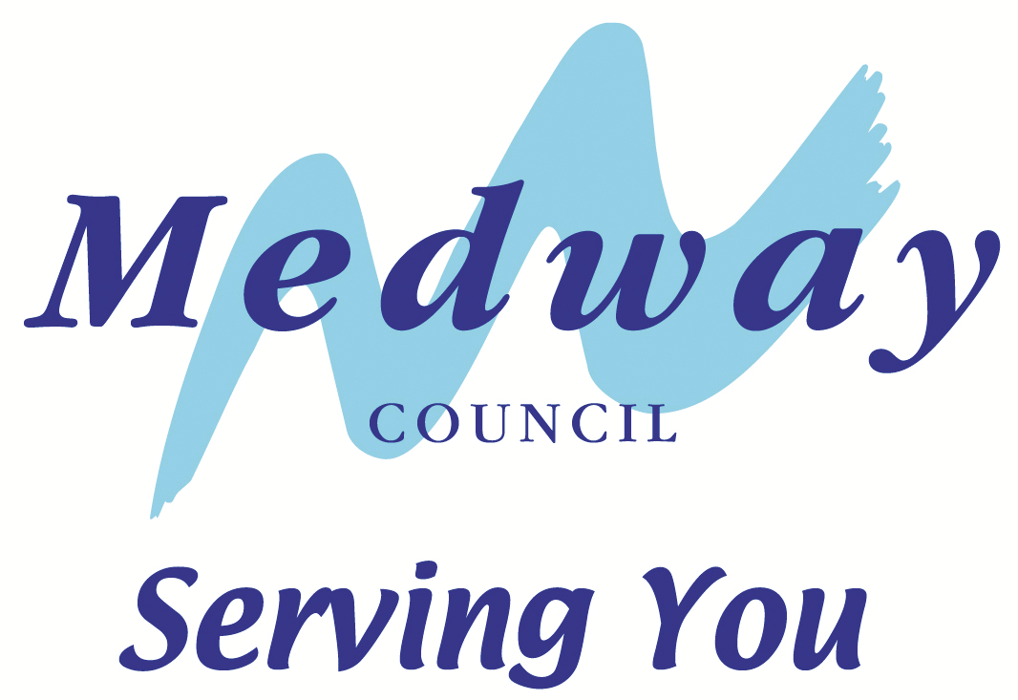

Distribution to

Armed Forces

Veterans

31 March 2019

Dear Veterans,

I am pleased to advise you that Armed Forces Day will once again be celebrated in Medway with a special gathering of the Armed Forces and Veterans on the **Great Lines Heritage Park in Gillingham** on Saturday 29th June. The event is once again promoted by Medway Council with the valued support of the Royal School of Military Engineering Chatham and many other armed forces units from around Kent. As always this will be a free entry event for the entire community.

Activities will include the traditional Military and Veterans parade at 12.30, a drumhead service, armed forces display’s, forces charities, band concerts, historic military vehicles, arena displays, a family funfair and the immensely popular Veterans Hospitality Area. All in all, we have a good old-fashioned community event planned in tribute to the ‘Armed Forces Family’.

Veterans and Standard Bearers are invited to join the short parade which is scheduled to commence at 12.30pm. This will be followed by a service which is expected to end at about 1.15pm. Displays and activities will continue through the afternoon. Standard Bearers are also invited to participate in the Musical Finale at 4.30pm.

**NB** – Standard Bearers wishing to take part in the parade and/or the Musical Finale should confirm their intention to do so to wjfowler1@gmail.com or to the address at the top left of this letter.

We are keen to see as many veterans as possible enjoy this occasion and to that end I would ask you to pass this communication on as widely as you are able to your colleagues in the veterans’ community. Attached to this letter are details for the event, parking and travel advice and a copy of the Veterans Parking Pass, for distribution to veterans only please.

Yours Sincerely,

**William J Fowler**

**William J Fowler**

**For Medway Council**

**These are the Veterans’ Admin Instructions for the Medway Armed Forces Day Celebrations on the Great Lines Gillingham on Saturday 29th June 2019. Please feel free to pass them on to your fellow veterans who might like to join us on the day.**

**Admin Instructions for Veterans**

1. **Daytime Programme** - The daytime programme commences at 11.00am and will close with an End of Day Ceremony in the Main Arena at 4.30pm which is scheduled to end by 5.00pm. There will be a programme of music and entertainment throughout the afternoon. There will also be a variety of display stands presented by the armed forces, historical societies and service charities.
2. **The Parade** - Marching contingents and Standards will muster on the grass at the Brompton Road end of the Garrison Fields at 12.15pm. The Parade will commence at 12.30pm. The parade will follow the footpath across the Garrison Fields and into the Main Arena for a short Service. The parade route is over a fairly short distance of about 300 yards.
3. **Seating** – There will be some seats available inside the arena for marching veterans who require one.
4. Non-marching veterans and their guests may participate in service which is scheduled to commence shortly after 12.30pm. The service should last no longer than about twenty minutes.
5. The Drumhead Service is open-air. Participants and spectators should dress accordingly.
6. At the end of the Drumhead Service the Parade Sgt Major will request permission to march the parade off the ground. The parade will then march past the dais and depart the arena for dismissal.
7. Following the Drumhead Service all members of the armed forces with a guest, and all Veterans, again with a guest are invited to the hospitality area where light refreshments will be available. Entry to the hospitality area will be available to veterans who are recognisable as such by way of an MOD Veterans Badge, or other means such as an Association Membership Card.
8. **Parking for Veterans Cars and Mini-buses.** See the separate Veterans Parking & Public Transport Information sheet
9. On the day, information and assistance may be obtained from the Medway Council Stewards.

**Further pre-event advice can be obtained from**

**Bill Fowler on 01634-570085 or 07930-415031**

**MEDWAY ARMED FORCES DAY – 29 JUNE**

**VETERANS PARKING & PUBLIC TRANSPORT INFORMATION**

This advice is intended to assist you in getting to Medway Armed Forces Day, having a great time and at the end of the day to get away nice and easy.

**VETERAN PARKING** – Medway Council will suspend the parking charges and time restrictions on Brompton Road for Veteransvehicles displaying the **Veterans Parking Pass** which is attached on Page 4. Additional veteran parking is located at the Brompton Academy (formerly Upbury Manor School) in Marlborough Road. Blue Badge holders may also park at this location.

Veterans may apply for additional passes allowing them to park at these two location by application to either their group Secretary or to Bill Fowler on 01634-570085 or by email on [wjfowler1@gmail.com](mailto:wjfowler1@gmail.com)

Once the Brompton Road and Bromption Academy facilities are full veterans should park using the locations detailed below for which the above mentioned Parking Permit **will not** be valid.

**PUBLIC PARK & RIDE** – A park & ride service will operate from the Chatham Historic Dockyard car park – ME4 4TZ. This service will operate from 10am to 6pm on 20 minute cycles. Fare is just £1 per person return, with under 16’s free.

**PAY & DISPLAY PUBLIC CAR PARKS IN GILLINGHAM**

MEDWAY PARK off Mill Road ME7 1HL – 24 hr. Long stay of 8 hours+

CRONEENS off Station Road ME7 1YF – 24 hr. Long stay of 8 hours +

BRITTON FARM off Jeffery Street ME7 4PN – Short stay of 4 hours max

BALMORAL GARDENS off Randolph Road ME7 4PN – Short stay of 4 hours max

JEFFERY STREET off Jeffery Street ME7 1DD – Short stay of 2 hours max

**CHATHAM CAR PARKS - A SHORT WALK UP TO THE GREAT LINES FROM THESE**

WHIFFENS AVE ME4 4SF – 24 hr. Long stay

The Chatham car parks are close to the Chatham Bus Station from which buses serve the event venue

TOWN HALL – 24 hr. Long stay

GUN WHARF – 24 hr. Long stay

PENTAGON MULTI-STOREY – 24 hr. Long stay

RIVERSIDE off Medway Street – 24 hr Long stay

**CLOSEST RAIL STATION IS GILLINGHAM** – 10 minutes walk

**ARRIVA BUSES TO THE EVENT (Always check with the operator for latest information)**

101 from Maidstone via Chatham; 116 from Hempstead Valley Shopping Centre via Rainham; 120 from Rainham via Chatham; 121 from Rainham via Gillingham; 182 from Twydall; 176 from Walderslade with closest stop in Canterbury Street; 136 from Gravesend via Strood to Chatham Waterfront; or any of the many other services calling at Chatham Waterfront Bus Station with connections to Brompton Road Gillingham.

**Medway**

**Armed Forces Day**

**29th June 2019**

**VETERAN PARKING PASS**

**Brompton Rd & Brompton Academy**

This vehicle is exempted from parking charges and time restrictions at the above locations for the purpose of

Medway Armed Forces Day on 29 June

This pass is strictly for the use of veterans only and is to be

clearly displayed on the dashboard of their vehicle





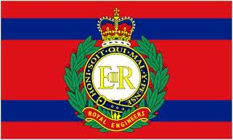

BAE Systems logo

BAE Systems logo

Cut here >--------------------------------------------------------

Print in COLOUR only NOT in black & white

Your co-operation in ensuring this pass is only made available to bone fide Veterans will be much appreciated as we strive to ensure there is enough parking close to the venue for our veterans.

We strongly advise veterans to car share where ever possible