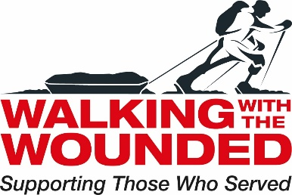

Job Description

Job Title Strategic Pathways Assistant (Scotland, NI, North of England)

Reports to Strategic Pathways Manager

Based at Gateshead WWTW Hub

Job Purpose | To provide programme assistance to the Strategic Pathways (SP) Manager to ensure the successful delivery of the SP project.

Primary Responsibilities | - To provide information, advice and guidance to bidders and grantees of the Positive Pathways funds.  - To maintain a database of application queries  - To promote collaboration within the Positive Pathways application process  - To provide administrative support to the Strategic Pathways Manager  - To track support provided by WWTW in order to report back to funders  - To facilitate partners networking meeting (likely two per year)  - To develop online resources for applications, such as online FAQs and other materials  - To provide a project support function.
Key Skills, Qualifications and Experience | Essential  - Proven experience in project management  - Competency in Microsoft applications including Word, Excel, and Outlook  - Excellent verbal and written communications skills  - Ability to initiate and manage influential external relationships  - Attention to detail  - A willingness to develop relevant knowledge and skills to support the proficiency of data entry onto the Salesforce system.  - Enter information/data from paper records onto Salesforce in a timely and efficient manor to ensure the information on the system is accurate and relevant.  - Maintain and develop the existing Salesforce database, ensuring new and existing records are complete to allow Managers to generate accurate data reports.  - Review and update contact records to ensure the information we hold remains accurate and up to date in compliance with GDPR legislation.  - Superior organisational skills  - Experience strategic planning  - Works well to deadlines and under pressure  - Car user and access to a vehicle  Desirable  - Empathy with vulnerable Armed Forces veterans and an understanding of the challenges they face in overcoming barriers to successful transition.  - Experience in the third sector.

