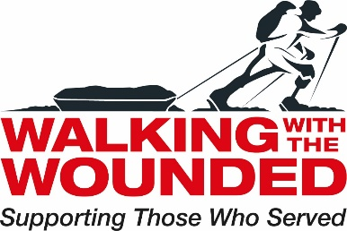

Job Description

Job Title Strategic Pathways Project Manager (Scotland, NI, North of England)

Reports to Director of Operations

Based at Gateshead WWTW Hub, with regular travel to NI, Scotland and across the North of England. Occasional travel to Southern England.

Job Purpose | To provide professional advice and guidance to enable potential applicants of the Positive Pathways Grants to submit their best quality applications. To mentor grantees and drive collaboration to enable joined up working between potential and successful bidders.  To provide leadership within WWTW ongoing business development across our wider portfolio of support programmes.

Primary Responsibilities | - To coordinate the Strategic Pathways (SP) project across NI, Scotland and Northern England  - To provide guidance, advice and clarity to potential bidders  - To deliver a quality, responsive and professional service on behalf of AFCFT  - To hold the SP programme overview so as to ensure WWTW delivery the best possible support  - To provide mentoring to successful grantees  - To develop online and printed materials to support bidders  - To work with other SP partners, including the AFCFT  - To develop quarterly network meetings (SP grant holders)  - To support WWTW income generation of our support programmes through business development  - To manage an assistant  - Appraise team members' performances and offer feedback to employees and, when appropriate, to manager  - To support grantees with their exit strategy  - To ensure that the programme meets WWTW professional standards and reporting requirements  - To work collegiately with members of the fundraising team with a view to ensuring continued funding for veteran services.
Key Skills, Qualifications and Experience | Essential  - Strong interpersonal skills with the confidence and ability to meet and talk face to face with a range of people - business people, trustees, beneficiaries and donors.  - Exceptional organisational skills - managing competing priorities and own workload.  - Experience of stewarding, managing and closing new business in face to face meetings with senior decision-  - Proven experience in program management  - Proven stakeholder management skills  - Proven experience managing a team  - Competency in Microsoft applications including Word, Excel, and Outlook  - A willingness to develop relevant knowledge and skills to support the proficiency of data entry onto the Salesforce system.  - Enter information/data from paper records onto Salesforce in a timely and efficient manor to ensure the information on the system is accurate and relevant.  - Maintain and develop the existing Salesforce database, ensuring new and existing records are complete to allow Managers to generate accurate data reports.  - Review and update contact records to ensure the information we hold remains accurate and up to date in compliance with GDPR legislation.  - Excellent verbal and written communications skills  - Ability to initiate and manage influential external relationships  - Attention to detail  - Superior organisational skills  - Experience strategic planning  - Works well to deadlines and under pressure  - Car user and access to a vehicle  Desirable  - Empathy with vulnerable Armed Forces veterans and an understanding of the challenges they face in overcoming barriers to successful transition.  - Experience in the third sector.

