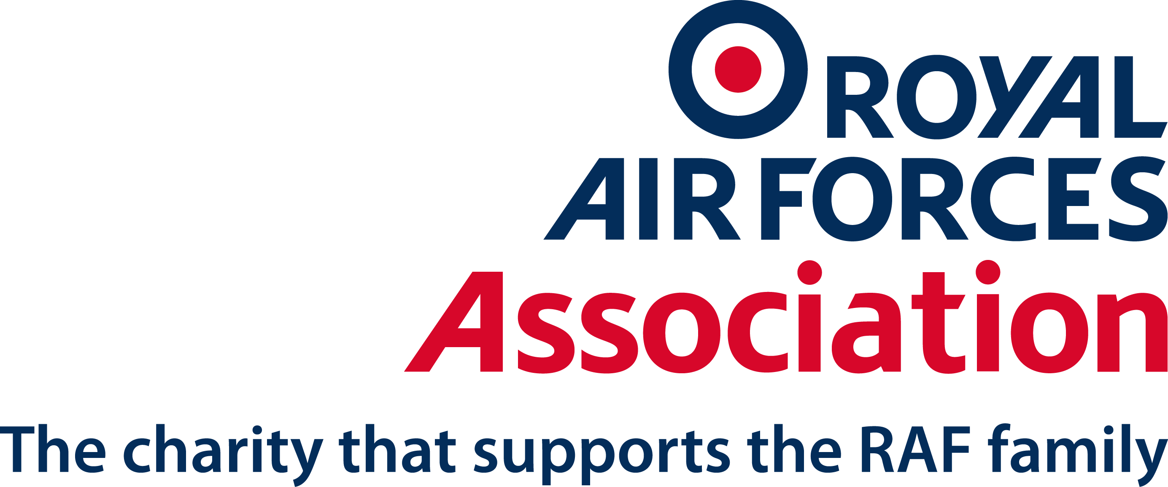
The Royal Air Forces Association

Application for Employment

Please fill in the application form below and return it to jobs@rafa.org.uk. This can be typed or handwritten.

If you would like this form in large print, please phone us on 0116 268 8754 or e-mail us at jobs@rafa.org.uk.

Position

Location

Personal Details

Title

Surname

Other Names

Address

Postcode

Email

Home Phone Number

Work Phone Number

Mobile Phone Number

Do you have the right to work in the UK?
Note: Evidence will be checked before a job offer can be confirmed

Why are you applying for this position at the RAF Association?

Education & Professional Qualifications

List all qualifications relevant to this position

Subject/Qualification | Result | Year Obtained

Membership of Professional Organisations or Other Body

Please provide details of any relevant professional registration you hold

Employment History

Current/Recent Employer
Address |  | Job Title
Address |  | Date Started
Address |  | Date Left
Address |  | Salary on leaving
Address |  | Length of Notice
Type of Business |  | Telephone
Reason for Leaving(if applicable)
Brief description of duties

Previous Employment (last 5 years)

From | To | Employer & Position Held | Salary on Leaving | Reason for Leaving

Supporting Information

Please evidence how you meet the essential and desirable criteria for this position. This can include knowledge, skills, experience, voluntary activity, training etc.

Driving Licence

Complete only if the person specification identifies you are required to drive on RAF Association business

Do you have access to a vehicle which can be used for work purposes and is insured for business use? | YES/NO
Do you have a valid driving licence for the UK? | YES/NO
How many penalty points do you have on your driving licence currently?
Please state endorsement code and date of issue of any penalty points
Please specify the vehicle categories for which you hold a license? List them all

Rehabilitation of Offenders Act 1974
You are not legally obliged to disclose convictions or cautions which are protected(filtered) or have become ‘spent’ under the Exemptions Order, unless you are applying for a position which is identified as being an ‘eligible position’ under the relevant legislation. If you are then a separate declaration is attached for completion.

Do you have any convictions, cautions, reprimands or final warnings that are not “protected” as defined by the Rehabilitation of Offenders Act 1974 (Exceptions) Order 1975 (as amended in 2013) | YES/NO
Details

Declaration

The information in this form is true and complete. I understand that any deliberate omission, falsification or misrepresentation in the application form will be grounds for rejecting this application or my subsequent dismissal if employed by the RAF Association
Signature

Name

Date

Guidance notes to help you complete the RAF Association Application Form
These notes are here to guide and support you with the best possible application. We strongly recommend that you read them before you start.
Before you start
Read carefully all the information about the role, especially the job description and person specification, which lists the skills, knowledge, experience and qualifications needed. Please contact us if you haven’t received the job description and person specification.
Your application form and supporting statement are the only pieces of information we will have about you as we do not accept CVs. Unless you clearly demonstrate in your application how you meet the requirements of the post you may not be shortlisted.
- Completing the application form
Read the application form carefully before you start. We select candidates for interview on the based on evidence and good quality information in support of your application.
1.1 Personal details
It is important that you fill in this section accurately and in full. Please ensure you give details of where you can be contacted. The more information you give the better. Please do not leave any section blank. If it is not applicable please indicate with N/A.
1.2. Why are you applying for this position at the RAF Association
Please tell us why this particular position with the RAF Association interests you
1.3. Education & Professional Qualifications
Give a list of all the qualifications you possess and relevant training courses you have attended. Information here will be used to assess whether you meet the qualification requirements in the person specification. Ensure nothing important is omitted. Please note that you will be asked to provide originals or certified copies of relevant certificates as part of any offer of employment.
1.4. Membership of Professional Organisations or Other Body
Please complete this section if you hold any professional memberships which are relevant to the post for which you are applying.
1.5. Employment history
Start with your current or last employer and work backwards making sure the dates are in the correct order. Provide the job title with responsibilities and the period you worked for them. It is important that you provide an explanation for any gaps in employment. Any voluntary work undertaken may also be included if relevant.
1.6. Supporting Information
This is the most important part of your application as it is where you show how you possess the skills and knowledge for the role. Make sure you read both the job description and the person specification to ensure that what you write is relevant. You should avoid using acronyms and do not make any assumptions.
1.7. Driving Licence
Complete only if the person specification identifies you are required to drive on RAF Association business

1.8. Rehabilitation of Offenders Act

You are not legally obliged to disclose convictions or cautions which are protected(filtered) or have become ‘spent’ under the Exemptions Order, unless you are applying for a position which is identified as being an ‘eligible position’ under the relevant legislation. If you are then a separate declaration will be attached for completion

1.9. Declaration

You must sign this section. It is a declaration of the validity of the information in the application, and confirms that misleading information would be sufficient grounds for terminating employment.

- Sending your Application
Please send your completed application to jobs@rafa.org.uk or post it to Jobs, HR Department, RAF Association, Atlas house, 41 Wembley Road, Leicester, LE3 1UT.
- Next Steps
3.1. We endeavour to reply to all our candidates with the results of shortlisting within one week of the closing date.
3.2. If your application is successful, you will be invited for an interview on the date which is normally specified on the job advert, via e-mail.
3.3. Reasonable Adjustments: The RAF Association is committed to the Disability Confident programme. We want to remove any barriers to potential employment that you may face so please tell us how we may support you by making reasonable adjustments
3.4. You may be invited to a second interview if you are successful at your first interview depending on the role you have applied for.
- Conditional Offer
If you are successful after the interview, we will make you a conditional offer of employment which is subject to the following pre-employment checks:
- Proof of Right to Work in the UK - You will be asked to bring your proof of Right to work in the UK (a passport will suffice) to any of our offices or hotel closest to you or to take it to the Post Office for them to put it through their checking system. Details of how to do this will be provided to you
- References – we will require receipt of two satisfactory written references. You will be provided with a Reference Request Form to complete on which you should provide details of two people we may approach for references. One of the referees must be your current/ most recent employer or if this is your first job, your education establishment. We will only take up your references with you express consent.
- If relevant to the post:
- Rehabilitation of Offenders - If the post you have applied for is an “eligible position” (A post that is exempt from the Rehabilitation of Offenders Act 1974, as it involves working with vulnerable adults and/or children and young people). You will be sent the Rehabilitation of Offenders Act form separately to provide details of your conviction(s).
- Disclosure Check - Along with the above, you will also require a relevant disclosure check. For the Disclosure and Baring Service (DBS) check you will be sent a link through a third party called UCheck for us to conduct a check. You will also be provided with details of other documents we will need to see in order to conduct the DBS check. (There are separate checks for Scotland and Northern Ireland)
- Medical Suitability – Depending on the role you have applied for, you will be asked to complete a medical questionnaire or your doctor may be asked to consider the job description and comment on your medical suitability for the role. This is also to ensure that reasonable adjustments can be made should the requirement arise.
5 Use of Information
Information provided by you on the application form may be copied for use during the recruitment procedure. Once the recruitment procedure is completed, applicant data will be stored for up to six months and then destroyed. If you are the successful candidate, a copy of your application form will remain on your personnel record.

