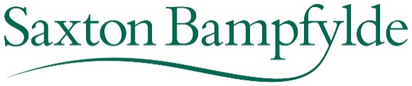

Appointment details

Company: Royal British Legion
Job title: Director of Membership
Job reference: UAONG
Closing date: 30 October 2020

Advert text

The Royal British Legion is at the heart of a national network that supports our Armed Forces community through thick and thin. As one of the UK’s best known charities, RBL serves a community of around 6 million people with a diverse and complex set of needs, operating as a national charity with a local footprint, helping veterans and proud to be the national champions of Remembrance. The Legion is currently developing the One Legion strategy with the aim of operating as one single organisation focussed on providing the best possible support and service for our ‘customers’.
RBL is now seeking a Director of Membership who will be part of this strategic change and who will reaffirm the great value our members bring to the Legion, revitalising their purpose and engagement by providing outstanding service and support to them as they help deliver on our charity’s purpose. The Director of Membership will lead the development of a model focussed on the unique role our members can play in providing comradeship and helping to engage new and more diverse audiences.
Skills and experience in leading transformational change within a complex organisation, and the ability to create capacity for the new model whilst ensuring engagement with a diverse range of stakeholders and building support will be essential.
This is a senior leadership role. The ability to inspire a shared vision as well as the influencing skills, communication and stakeholder management are essential qualities for this role. The ideal candidate will be able to demonstrate the highest level of commitment to delivering the Legion’s purpose. Previous experience of serving or working with the armed forces community would be desirable but not essential. They will also have experience of working across a large, complex organisation (public, private or 3rd sector) and will be able to demonstrate the contribution they have made across the organisation, not being limited to their functional responsibility.

Saxton Bampfylde Ltd is acting as an employment agency advisor to the Royal British Legion on this appointment. For further information about the role, including details about how to apply, please visit www.saxbam.com/appointments using reference UAONG. Alternatively telephone +44 (0)20 7227 0880 (during office hours). Applications should be received by noon on 30th October 2020

