DEPTHERAPY & DEPTHERAPY EDUCATION
END OF YEAR REPORT
2021

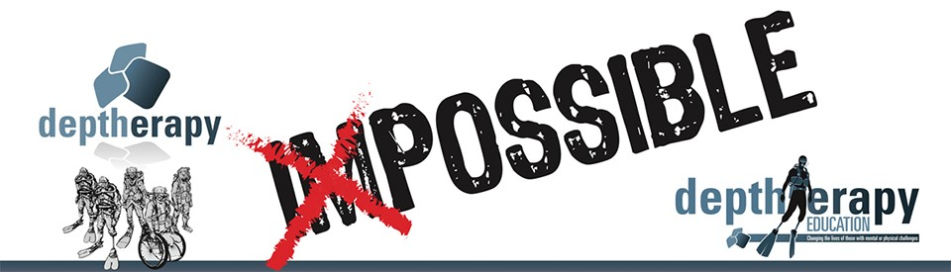

WELCOME TO OUR WORLD

“The Road Goes Ever on!”
Tolkien – Lord of the Rings

I hope you have all enjoyed a very Merry Christmas and a Happy New Year.

Deptherapy’s new year, starts as usual with a look back on our previous year’s work, in this report, 2021. I have also taken the opportunity to look at what the Board believes is Deptherapy’s ‘living legacy’.

Please remember our achievements in 2021, which have been substantial, were delivered by us, as a totally volunteer led and run charity.

Introduction

2020 was an abysmal year, with COVID destroying our planned activities. We had all hoped for a respite in 2021 and a return to some sense of normality. That was not to happen, and in the early months of the year we saw the same cycle of booking flights and expeditions only for them to be cancelled and rebooked. This on/off situation had a major effect on the wellbeing of several of our beneficiaries.

Deptherapy is indebted to you

Normally I would say thank you to our funders and grant makers later in the Annual Report, this year is different. Grants from the Armed Forces’ Covenant Fund Trust and the Veterans’ Foundation have provided us with a beacon of hope in these dark, COVID times. The Veterans’ Foundation have supported us since 2017 and the AFCFT since their inception. This has meant that we can deliver the benefits we deliver to an increasing number of Veterans. I will return, later, to the Grants and what we seek to deliver as a result of them.

I also want to say a huge thank you to the Invictus Games’ Foundation, who are our strategic partners and who absorbed the Endeavour Fund in 2020.

I probably shouldn’t name individuals but I am going to: Megan, Rachel and Lorna at the AFCFT; Rachel at Cobseo; Sarah at the Veterans Foundation; Naomi at the Invictus Games’ Foundation. There are many, many more. The Deptherapy Board and
our beneficiaries want to say a huge thank you for your continuing support.

We also want to thank the members of Ilkeston and Kimberley Sub-Aqua Club for their sterling fundraising support during the pandemic.

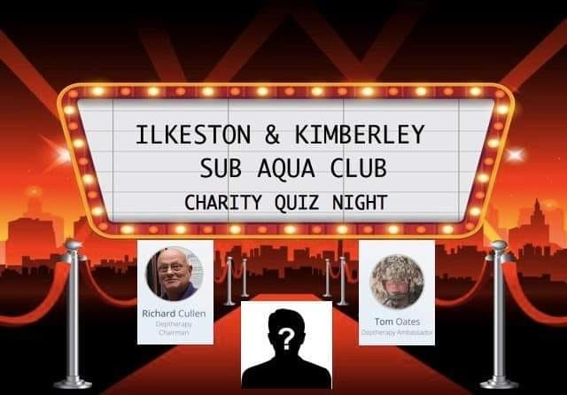

To the Deptherapy Team

I include the Board that comprises of our Trustees, our Associate Directors, our President, and VPs. I also want to thank our team of volunteers, the instructors, the Divemasters and supporters. Without the commitment of the Board and the instructional team we could not deliver and achieve what we do.

2020 saw Sharon have a knee replacement and rehabilitation has been challenging. Michelle, one of our instructors, has been fighting a huge battle with ill health throughout the year supported by her husband and fellow Deptherapy Instructor Carl. Michelle, I think you know you have the support of everyone involved in the charity.

It is so easy to be negative

As a Board we look at both 2020 and 2021 as providing us with huge challenges, not only in terms of logistics but also in respect of the charity’s continuing viability. COVID has seen many small charities close, fundraising and sponsorship has dropped massively. ‘Small Charity’ in terms of the COBSEO definition does not adequately describe Deptherapy, we are and always have been a ‘micro charity’. We have no paid CEO and Directors to deliver and market our products, we are a totally severed stumps wrapped in thick volunteer lead and run charity. We cannot afford the luxury, that large charities in our sector have of running advertising campaigns and producing marketing videos. Raising funds is a competition and in a continuing extremely difficult ‘giving’ situation we will struggle to secure funds to secure our future.

We accept this challenge and however difficult the situation may become we can look at the legacy we have produced since we were first created as a ‘small charity’ in 2014.

Let’s be positive, this is our legacy

“You don’t know me I am ‘X’s’ mum. I saw your post today offering him support. I don’t know how to thank you for all you do for him. Without you, I doubt he would still be with us. The admiration he has for you and Deptherapy says a lot for your team and what you do. From a mum who thought she had lost her son, thank you from the bottom of my heart.”
November 2021 from a beneficiary’s mother.

I love the photo on the front page of this report. It is of myself with Chris Middleton, on a dive boat in Chuuk Lagoon, in 2018. It conveys happiness, but to me and the Board it conveys something far more. I first met Chris three months after an IED explosion had taken both of his legs. That first meeting took place at Headley Court as I came through reception, I was met by a very young man, in a wheelchair with his severed stumps swathed in bandages. Little did I know that this meeting would lead to the creation of Deptherapy and in terms of the scuba diving world lead to a change in how we approached scuba diving for those with mental and or physical challenges.

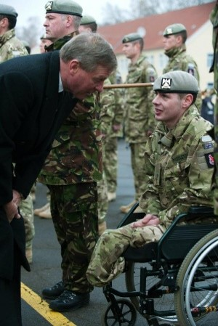
Chris (2012) talking to a MoD Minister

Chris and I have developed a strong friendship, one which for both of us has been an adventure. It took Chris a long time to admit he had PTSD and to seek the professional help that he required. Chris is known as ‘Tigger’ within the Deptherapy family, after A.A. Milne’s character of the same name as he is always bouncing around.

Chris is very clear that Deptherapy not only changed his life, but saved his life.

‘Tigger’ is an essential ingredient of what we do. Chris is highly motivated and progressed rapidly to become a Divemaster. To achieve the required standards for the timed swims he had to swim at County standard for a swimmer with his level of disability. His skills were assessed by an independent instructor and he scored straight 5s, the highest cumulative score the instructor had awarded.

Chris inspires new beneficiaries, his mantra is; “Look at me; if I can do it with two legs missing and chronic PTSD, so can you.” New beneficiaries are in awe of Chris when they see his abilities underwater. He is an effective and inspirational team leader.

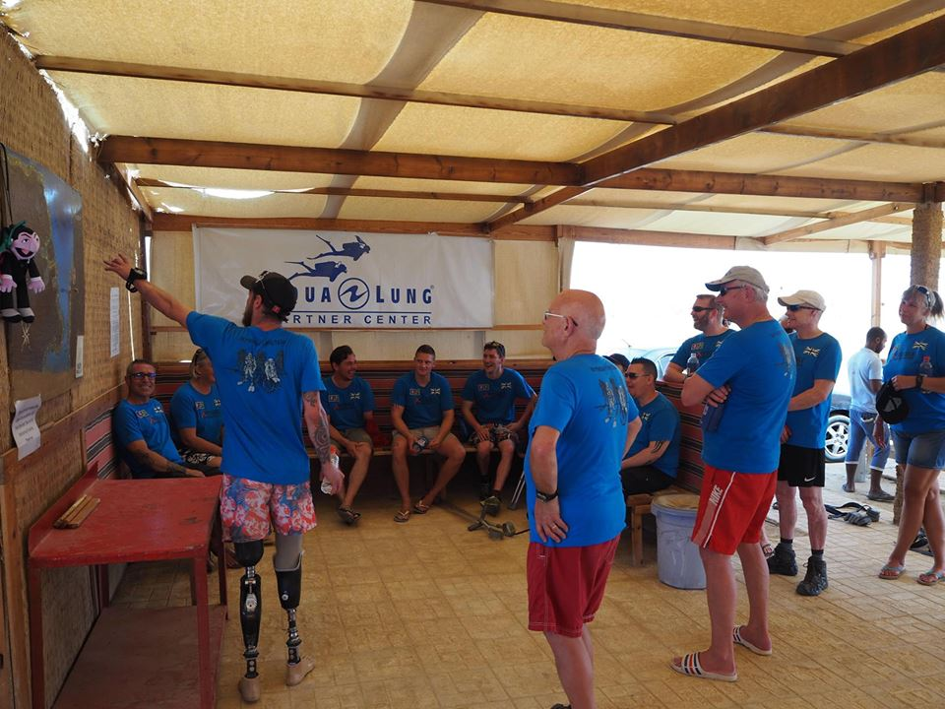Chris briefing a dive for new beneficiaries.

Chris’ determination that he did not want a certification card from Disabled Divers’ International made us look at how with his level of physical challenge he could qualify as an open water diver and achieve all the required standard. The work with Chris’ in those early days set the template for what now has Deptherapy acknowledged as the world’s ‘best’ adaptive teaching programme.

We haven’t seen Chris for a couple of years, partly due to COVID, but also because he is pursuing a new career opportunity. Deptherapy gave him the belief to take on challenges. He is now an accomplished wheelchair boxer and is working with the President of the WBC to have wheelchair boxing accepted in to the Paralympics. Fortunately, Chris will be joining us on our July 2022 Expedition to Roots.

Tom Swarbrick came to us, through the Endeavour Fund, in 2018, he was a broken man. The impact of PTSD on him had been devastating; he had lost the ability to trust and was unable to form relationships. In terms of working with Tom he provided the biggest challenge I have faced in getting him to trust and ‘open up’. He said the me once “I can’t cry, I have used all my tears”. What have we seen? Tom learned to trust again; he has become a valued friend; he has been in a relationship for the past three years. He is first in line if others need support. 2021 was challenging for Tom, two of his friends from his old Regiment took their own lives and one tried to do so.

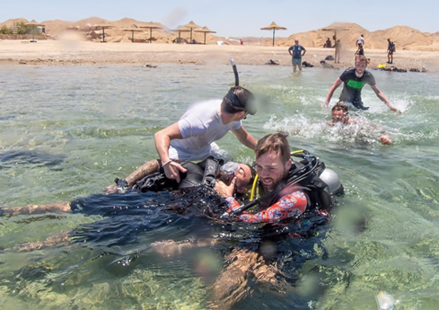
Tom Swarbrick (left) on his Rescue Course

Today, as I write this report, Tom is in Argentina to climb the 6929-metre-high Mount Aconcaqua. This would not have happened without Deptherapy. Tom is very clear about how Deptherapy has changed him and his life.

In 2018 Tom Oates, who has Chronic Complex PTSD, tried to take his own life. In the early days many doubted Tom’s ability to achieve. His childhood dream was to study marine biology. Deptjerapy opened the door for him.

He is now in his second year at Hull University studying Marine Biology. He leads for the beneficiaries on all matters marine biology as is leading a small team looking at destinations for our 2023 expedition. He is in a stable relationship and is getting married in July. Tom is one of our Mental Health Champions.

Tom, his partner and his parents are very clear that Deptherapy saved his life and turned his fortunes around.

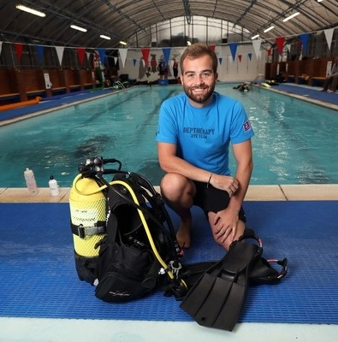
Tom at Eagle House School’s pool

Danny Martin, our other mental health champion is a cancer survivor and has Chronic PTSD. He had suicidal ideation before he joined the Deptherapy. He is now studying at University in Scotland and is very clear that Deptherapy saved his life; gave his wife her husband back and his children their father back.

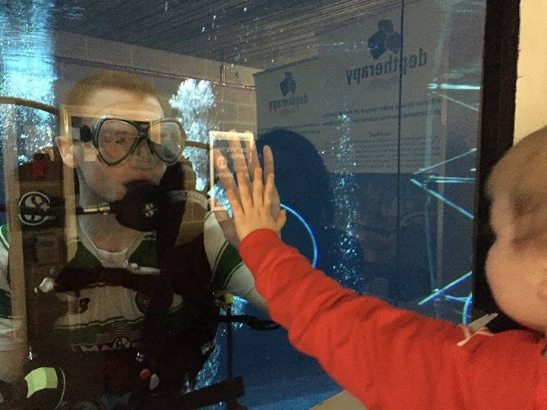
Danny and his son Jackson.

“Thank you for believing in me.”

A huge part of what we do is helping beneficiaries to believe in themselves. So many due to PTSD or physical injury have lost the ability to believe.

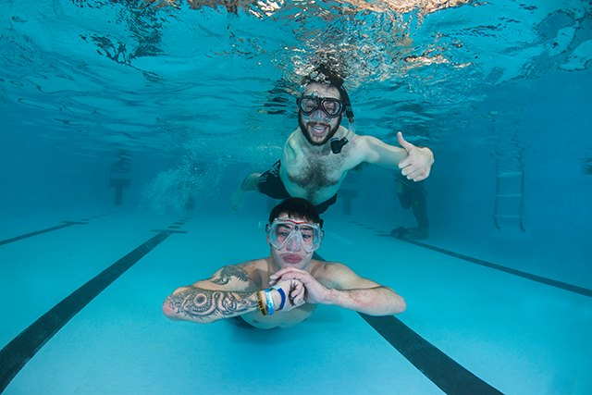
Danny (top) is a through the shoulder amputee

Danny Richards came to us through the Veterans’ Charity. He has a rare through the shoulder amputation. Motivated by Chris’ achievements he wanted to become an open water diver. One of the standards to achieve this certification is to swim 200 metres without stopping. That was a huge challenge for Danny.

The swim was taking place in one of Divecrew’s swimming pools where there were a number of non-Deptherapy courses running.

Danny was struggling, we encouraged the other divers to support him, the pool was filled with a cacophony of sound as divers cheered and clapped in support of Danny. With a Herculean effort Danny completed the swim. When he emerged from the pool the first words he said were:

“Thank you for believing in me!”

Those words sum up what we do.

We work with a huge range of challenges, both mental and physical, in some cases both. Michael Hawley, who as a beneficiary became a Trustee with responsibility for Programme Member Liaison. Michael has MS and Depression. As many will know MS is a progressive illness that at times goes into remission. When Michael first wanted to join us our doctors initially declined to issue a ‘fit to dive’ medical. Michael had to wean off a number of medications and show his condition was stable before he would be allowed to dive. He showed massive determination in reducing his medications and after two years was signed off as fit to dive.

Michael is stoic and a mainstay of the charity as he progressed through various levels of certification has asked if we thought he could possibly become a Divemaster given his MS. He wanted to show his daughter that even with MS he could still achieve.

Despite all the challenges his MS presented him with he did achieve and he is now one of our established and highly respected DMs.

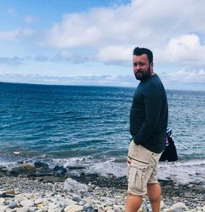
Michael at Roots

We could list many other individual cases but I think those set out above clearly show the legacy that is Deptherapy.

On a wider scale

Since 2016 Deptherapy has been the subject of a number of medical/academic studies:

- 2016 - Sheffield University Medical School; Alice Morgan et al
- 2019 - Notting University, Centre for Trauma Studies; Mary Barrie
- 2020 - East London University, Centre for Post Traumatic Growth; Petra Walker
- 2021 - Systematic Review of Previous Studies; Dr Richard Castle, Deptherapy VP
- 2021 Sheffield University Medical School

The latest study by Sheffield University only reported in December and is being finalised. The research will be submitted for publication and therefore the findings will, until formal publication, only be disclosed within publication guidelines.

A further study is planned for the Roots Expedition in July 2022.

A big thank you

I must say, on behalf of the Board a huge thank to Dr Richard Castle PhD AFBPsS C.Psychol, who is an independent consultant psychologist, specialising in trauma and is one of our Vice Presidents. Richard’s enthusiasm for the study programme and his contacts have provided us with a level of knowledge around sporting rehabilitation, particularly, through the medium of scuba diving that did not previously exist.

Richard in addition to carrying out the systematic review into the Deptherapy studies but also looking at other sporting rehabilitation studies was a major piece of research; He also has acted as supervisor to the two Sheffield University and has been the ‘key’ Deptherapy contact for the other studies.

Richard also runs our Mental Health First Aid Courses that are q pre-requisite for all Board Members, Instructional team and volunteers. In 2019 we opened these courses to beneficiaries and their partner/relative/friend.

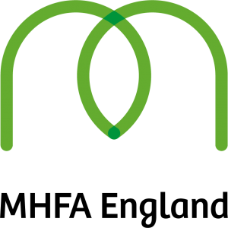

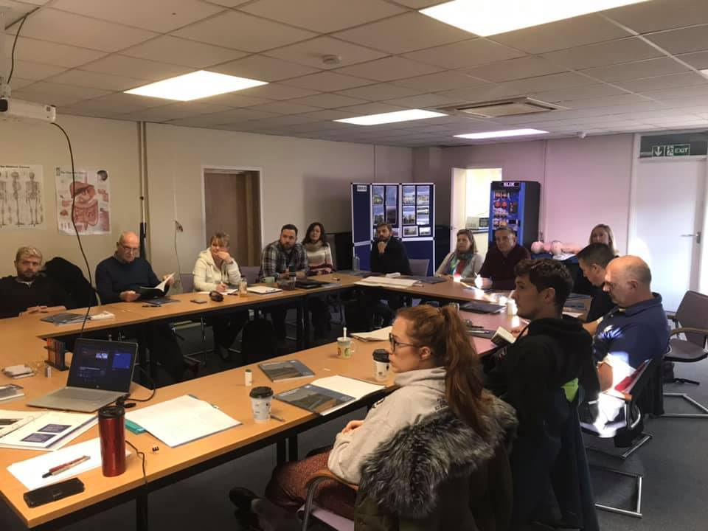
A Deptherapy Mental Health First Aid Course being run by our VP Dr Richard Castle

Studies into scuba diving and rehabilitation - prior to 2016

Only one study had been published into the benefits of scuba diving in rehabilitation. It was conducted by the John Hopkins University in the USA and looked at a group of US veterans who has suffered life changing mental and or physical challenges. The study reported positive, but limited benefits to the veterans but admitted that it only focussed on a couple of try dives and relied on an ‘end of course’ evaluation of the benefits.

During Richard’s systematic review it became clear that many vaunted ‘blue space’ rehabilitative studies, for example looking at surf boarding or ‘green space’ activities such as trekking relied for their evidence upon ‘end of course’ evaluation and did not look at long term benefits.

The 2016 Sheffield Medical School study is appearing in more and more research across the globe and is referred to as a ‘first’ in looking at during programme and post programme benefits and issues. For Deptherapy the study reinforced the need for our much-vaunted buddy peer support scheme as beneficiaries reported increasing anxiety on their return home after an expedition that manifested itself as a extreme form of ‘post-holiday blues’

Barrie’s 2019 research was observational based and Mary took part in an Open Water Course with beneficiaries based at our home in Egypt, Roots Red Sea. What it captures in a very vivid form is how the expedition team builds, how pride is created and how new beneficiaries are embraced. She talks about the flight to Egypt and how the beneficiary who sat next to her had ‘dark, hollow eyes. Her study highlights the developing community, the willingness of beneficiaries to talk openly about mental health issues and the importance of the ‘reflection room’. This effect and the Roots’ effect will be the subject of the 2022 study.

Walker’s 2029/2020 study follows a different path and looks at ‘The Calm’ this refers to the benefits of the scuba diving experience itself and how ‘demons disappear’ when beneficiaries dip their heads under the water. She makes an important point that Deptherapy delivers rehabilitative beyond those found in other sporting rehabilitation activities.

This study needs to be read in conjunction with the previous studies as they paint a broader picture of how the benefits that we deliver accrue.

The latest Sheffield University Medical School study is different again as it looks at the medium- and longer-term benefits of what we do. The cohort involved those who have ‘moved on’ from our programmes as well as those still on the programme. The results are outstanding but challenging questions are also posed.

2021 what we delivered

Our two-week Roots’ Marine Biology Course funded by the AFCFT was set for May/June, having been postponed from 2020 due to COVID.

Marine Biology Course cancelled

Dr Deborah McNeill from the Open Oceans Project leads on the marine biology aspects of our planned expedition. Deborah put a huge amount of work into an online study programme for beneficiaries that required a substantial amount of work for both Deborah and the beneficiaries. Deborah is creating a group of citizen scientists, who can be very proud of their work.

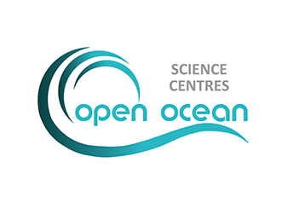
https://openoceanproject.org/education.html

We really appreciate Deborah’s, hard work, but sadly, the Government’s travel ‘traffic light’ system meant Egypt was firmly on the ‘Red List’. We had to cancel the expedition and reschedule for October 2021.

UK restrictions start to relax.

As COVID restrictions in the UK opened up and groups were allowed to meet the Board made the decision to run a RAID Open Water 20 course for our backlog of new beneficiaries. This was something completely new for us, we had never run and UK course before and we did not know whether benefits would accrue as they do in Egypt.

RAID Open Water 20 Course

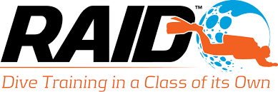

The logistics were a major challenge. Firstly, diving in open water, in the UK, even in the summer, requires dry suits. Due to the height and build of our beneficiaries we had to order tailor made dry suits through Divecrew. Divecrew also procured Eton College’s 4-metre-deep pool for us for the confined dives and the open water dives were run at the nearby Wraysbury Dive Centre.

Divecrew also provided all the other equipment required for the course. A local hotel was booked for the duration of the course with some beneficiaries travelling from the North of England and Scotland.

We had five students, four with mental health issues and one with MS. RAID Open Water courses are challenging and there is a requirement to complete a non-stop 200 metre swim. Unfortunately, the beneficiary with MS was unable to complete the swim. The team made the decision that he could continue to complete the confined water skills and if he committed to swim training, he could complete his swims and other skills when we again travel to Egypt.

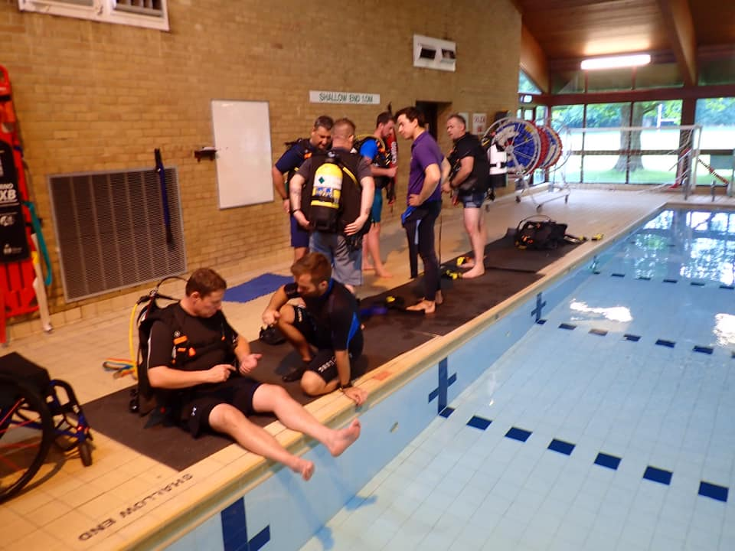
Tom Oates helping Grant kit up on poolside. While Deptherapy beneficiary and instructor Sean Martin (in tracksuit) supervises the other open water students at Eton pool.

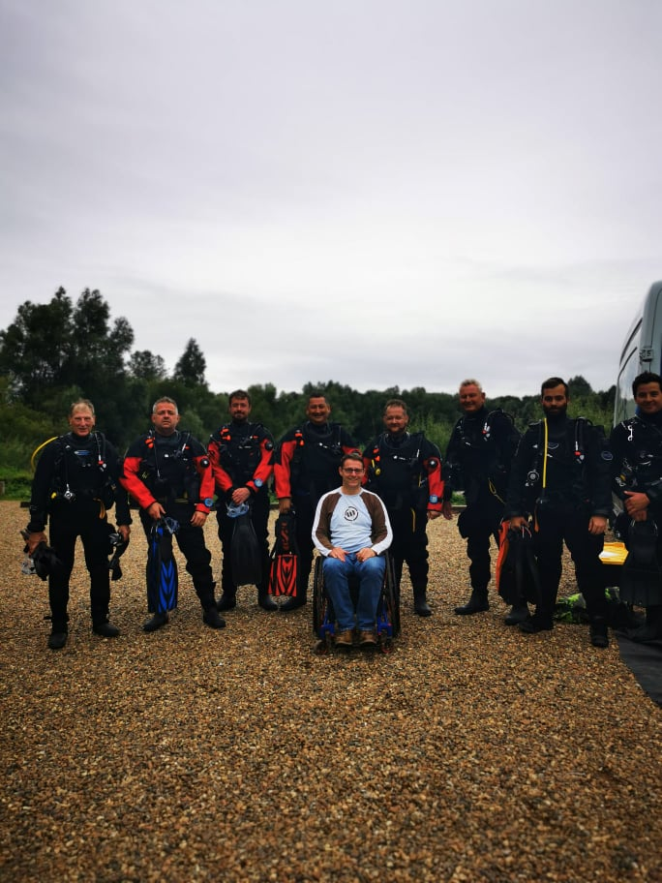
Beneficiaries in open water;& Instructors at Wraysbury Dive Centre

The programme was funded by our Veterans’ Foundation grant that was originally directed to delivering open water courses at Roots in 2020.

Jay, Nick, Gary and Iain successfully passed the course and Grant will undoubtedly do so in Egypt 2022.

MALTA - RAID Advanced Wreck Course

Malta was one of the first foreign countries to be taken off the ‘Red List’. In 2020 it had been planned that we would take a group of beneficiaries, who would be potential team leaders for our Red Sea Marine Biology liveaboard when we would dive the wrecks of the SS Thistlegorm and Turkia.

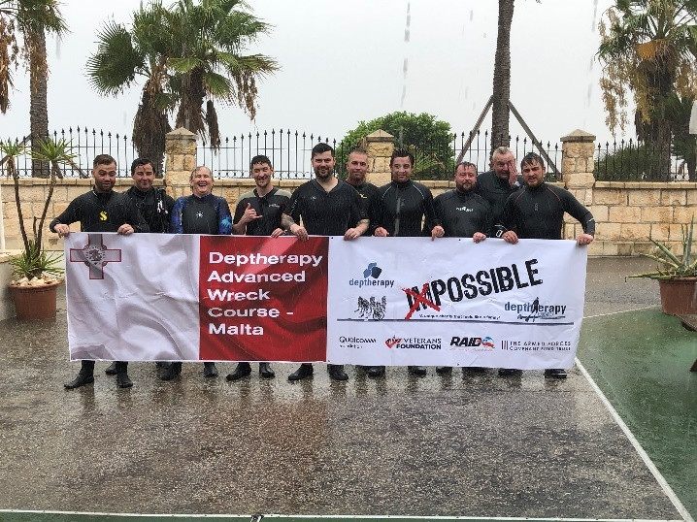
Eight beneficiaries taking part in the RAID Advanced Wreck Course in Malta

The original plan was that the course would be run in Egypt, but with Egypt still ‘red’ we organised a week’s course in Malta. Fortunately, we have good friends at Divewise in Malta and we were looked after royally.

What they could not organise was the weather and this played against us for much of the week.

The RAID Advanced Wreck Course is challenging for highly qualified, able-bodied divers even more so for those with physical and mental challenges. One of the high-level skills that must be mastered is to let go of the penetration line, while wearing a blacked- out mask, simulating extremely poor visibility in a wreck. The instructor disorientates the student and then the student has to recover the line. Once the line is recovered, the student, still wearing the blacked-out mask, has to establish, from tie off points or line markers, the direction of travel.

Imagine doing this skill if you have chronic PTSD?

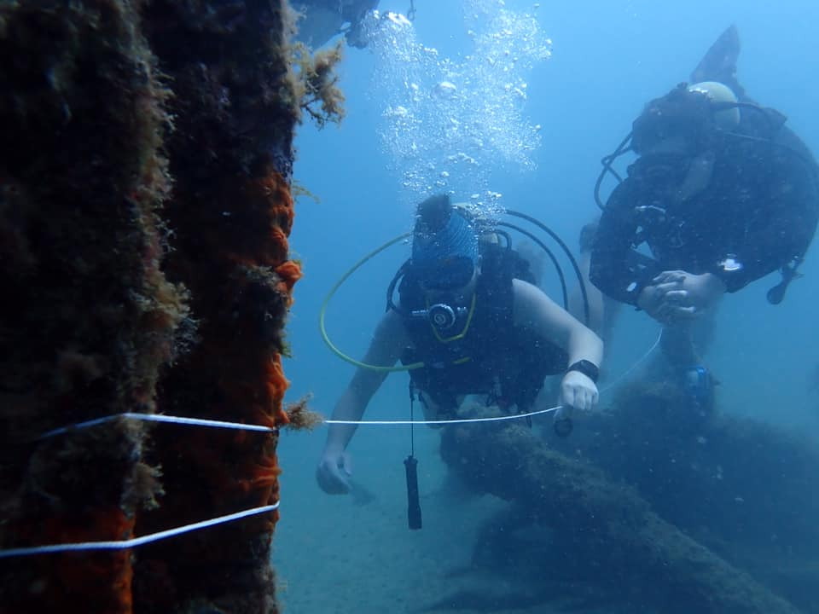
Tom Oates, Complex PTSD, approaches a tie off point on a wreck, wearing a ‘blacked out’ mask, supervised by Sean Martin

All beneficiaries were successful in passing the course.

British withdrawal from Afghanistan

Immediately prior to travelling to Malta and during the expedition, it became clear that the British withdrawal from Afghanistan had badly affected some beneficiaries. In the extreme it sparked an immediate response in some, such as flashbacks, nightmares and in one case night terrors.

For some this was very personal as they tried to understand why close friends had died in Afghan only for the UK to withdraw totally in 2021. For others there was all that I can describe as a ‘residual sadness’ as they looked back at their service in Afghan.

The withdrawal created a sense of ‘what we did, didn’t matter it was all worthless’ It created great self-doubt.

These feelings did place pressure on our ability to provide effective 24/7 support to beneficiaries.

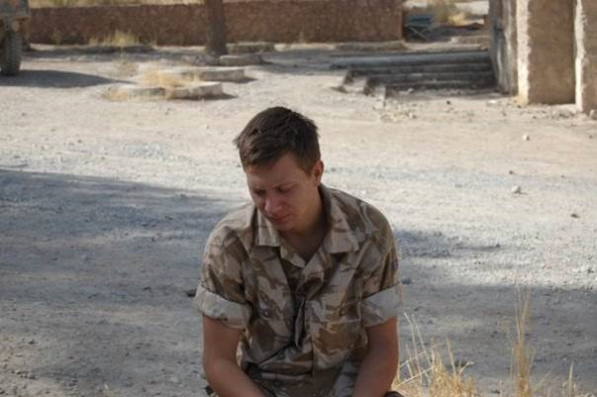
Kevin Pryke, chronic PTSD in Afghanistan

The Armed Forces Covenant Fund Trust wrote to organisations to announce a grant to specifically deal with problems created by the Afghan withdrawal.

We applied for a grant and we were successful. We greatly appreciate the generosity of the AFCFT as this will allow us to offer high quality mental health programmes to our beneficiaries.

Richard Castle leads on this project on behalf of the Board and we will deliver:

- Mental Health First Aid Courses and refreshers for beneficiaries, partners or relative + to our team of volunteers
- A ‘retreat’ for beneficiaries and partners to discuss mental health problems and coping mechanisms generally.
- Additional training for senior beneficiaries who act as ‘buddies’ in a Buddy Peer Support Programme
- Online help for beneficiaries who are in need of support.

In the New Year we will contact each beneficiary, past and present and seek to develop a tailor-made package for those wishing to take part in the programme.

MHFA is the model we use to support our beneficiaries and we aim to ensure we can provide the support that they need, when they need it.

Grenada – The Spice Island

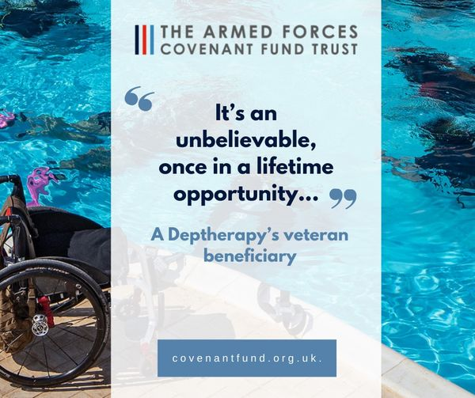
It certainly was a ‘once in a lifetime opportunity.

Just prior to our Malta expedition we became aware that Egypt would probably stay ‘red’ which meant our October expedition would not happen. Had we waited until October to see if Roots would go ahead and then tried to book another destination for our AFCFT programme we would not have found a venue in 2021. With the help of Regal Dive, we looked for destinations that were on the ‘green list’ and provided the coral and aquatic life we needed for our study.

Regal identified Grenada as being suitable and he made a proposal to the AFCFT to move our 2021 programme to the Spice Isles. Throughout COVID AFCFT have been unbelievably helpful and understanding of the challenges we faced in confronting COVID restrictions.

We had to perform a scramble to get names and details to Regal and BA, our last day in Malta saw the team working flat out on admin to make Grenada happen.

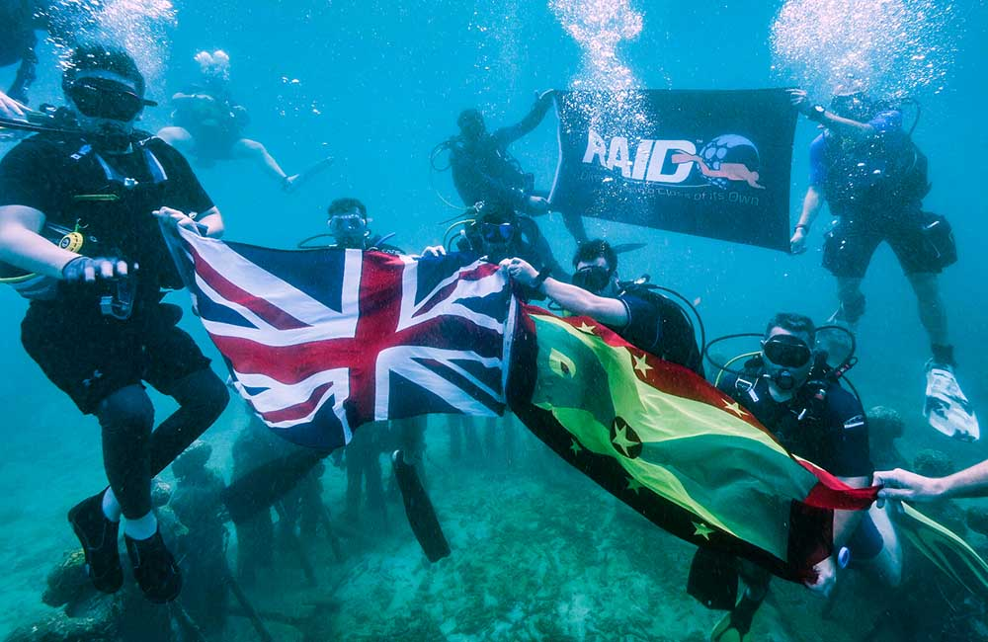
Beneficiaries ‘raising the flags’

Some of the original group of beneficiaries were unable to make the Grenada dates and others, not believing that Egypt would go ahead, had made other arrangements for the dates. We therefore needed to select some replacements. The team selected Gary Daye and Nick Lindsay. Both had been on their Open Water Course in August and at their level of experience, would in normal circumstances not have been considered for an expedition at this level. The team decided they were by far the best students on the open water course and should be offered places on the expedition. The offer was conditional on them completing their RAID Advanced 35 courses at the beginning of the expedition along with Corey.

BA provided us with a dedicated check in desk and speedy boarding which was much appreciated.

Grenada and COVID

If you think the UK had tough restrictions around COVID then Grenada had twice as many including curfews and a requirement to wear masks in public. Strict proof of COVID status was required as well as a negative PCR test on entry which required quarantine in our hotel until the results became available.

True Blue Boutique Resort

A very much open planned resort where the management and staff could not have been more accommodating. The staff at the resort were brilliant and we were just given the best possible reception, COVID permitting, that anyone could ask for.

The resort went out of their way to make sure we received the necessary COVID clearances and organised a ‘fast track’ through the COVID testing at the airport.

Aquanauts Divers

The centre is based within the True Blue Resort, literally a couple of minutes from our rooms. We had a great discourse with them prior to travelling and our adaptive needs. A family operation with father Tom and daughter Tiffany providing great support.

All the Aquanauts’ team were exceptional and provided support with Corey’s needs as a wheelchair user.

I must mention the boat captain Bruce, he was a larger-than-life character who could bring a smile to anyone’s face. The beneficiaries loved him

The Resort and the dive centre made the expedition a very memorable occasion. During quarantine we were given exclusive use of a pool, a few found that they had stayed in the sun for too long.

It was a special ten days but it was made more special by the support we were shown by the Grenadian Government.

The Grenada Tourist Authority became actively involved in our expedition and their CEO Petra Roach came to the Resort to welcome us all to Grenada. Petra made a real impression with the beneficiaries and team. She showed a real warmth towards us and what we do.

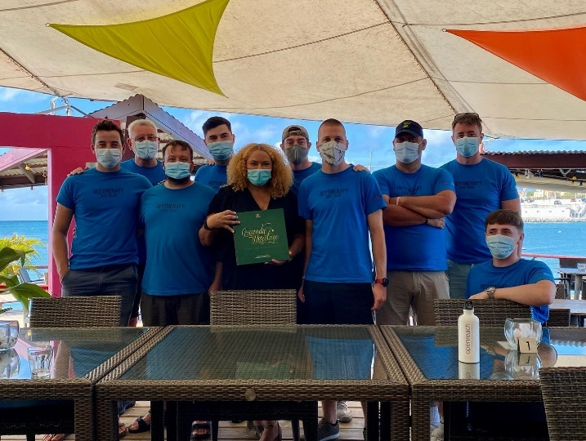
Beneficiaries with Grenada Tourism Authority CEO Petra Roach

Petra returned the next day with Grenada’s Minister for Tourism Dr Clarice Modeste-Curwen who met and addressed the beneficiaries The Minister presented us with a book telling the history of Grenada.

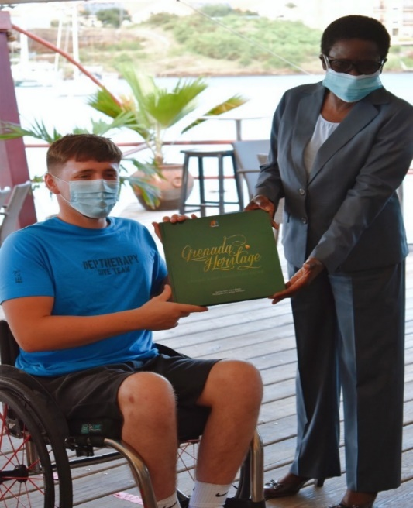
Corey and Dr Clarice Modeste-Curwen

It is easy for people to think that Deptherapy is about scuba-diving holidays, it is not. If you take out the rehabilitation work and just look at the diving, there is studying and courses to undertake. On the Grenada expedition:

- Three beneficiaries had to undertake pre-expedition studying for the RAID Advanced 35 Course and while in Grenada complete five qualifying dives, three at 35 metres.
- One had to complete the RAID Deep course
- Six had to complete the RAID Enriched Air (Nitrox) Course

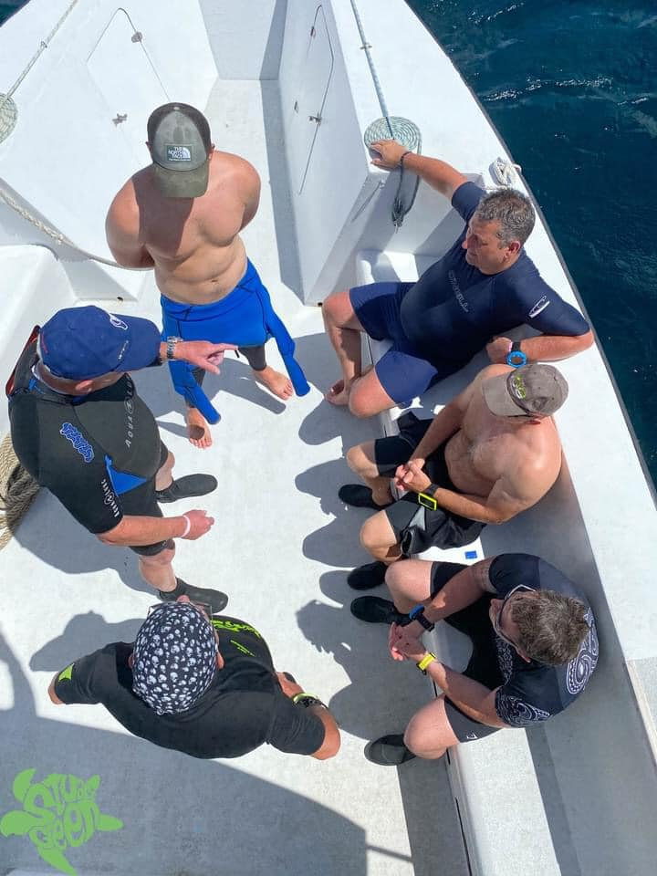
Martin and Sean debriefing a dive on the Advanced 35 Course

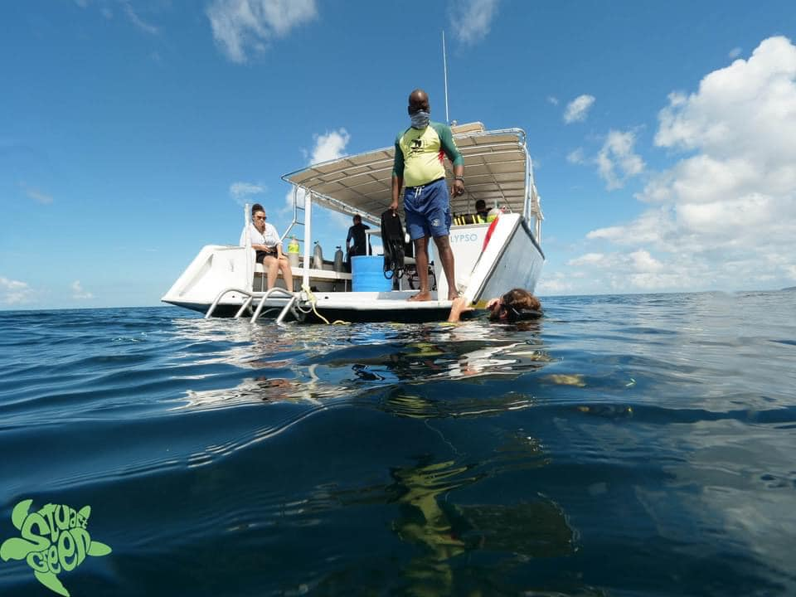
Clear, warm water (28 -29 degrees)

The work does not end there all had to study fish ID and data collection methods for the bio mass study we were to complete on one of the reefs.

There were also a series of lectures and a major exercise in dive planning and air consumption.

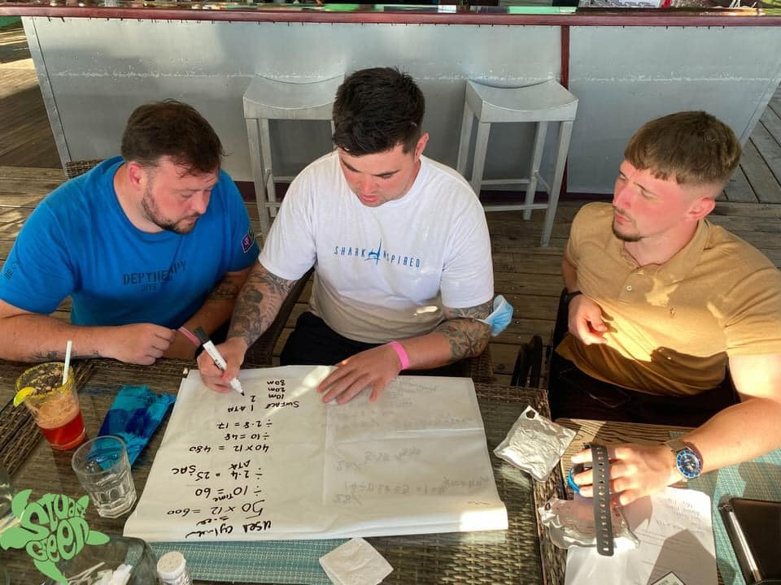
Jason, Michael and Corey working through a dive planning exercise

This requires detailed analysis of data, mathematical calculations and dive planning for a team of divers.

Bio Mass Study

The marine biology survey of one of the reefs was an essential part of the 10 days in Grenada. Tom Oates who was to lead the project tested positive for COVID two days before we were due to fly to Grenada. Tom had already prepared a PowerPoint presentation and identified target fish and data collection methods.

Prior to the two days of the exercise Tom gave a briefing to everyone via the Zoom platform with Jason Court taking responsibility for the on-site briefings and management of the exercise. The team worked with Aquanauts to identify a suitable reef.

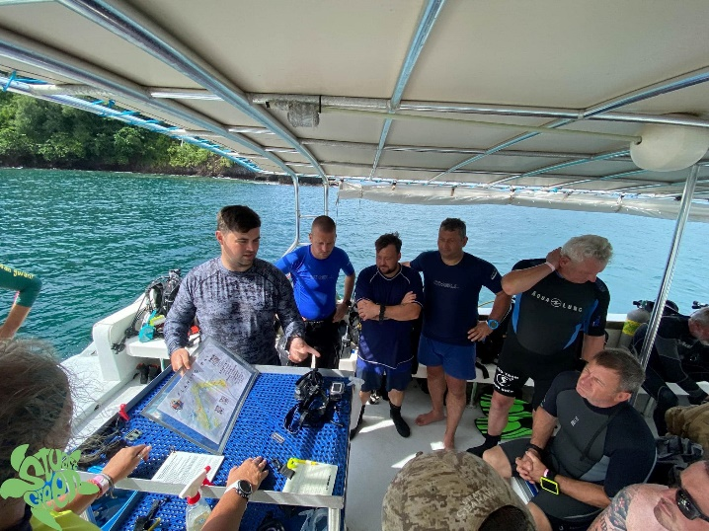
Jason briefs beneficiaries – Dive 1 Marine Biology survey

The enthusiasm for the study, combined with our experience in Chuuk Lagoon and beneficiaries studying with Deborah McNeill very much points to this type of project being the future of Deptherapy’s work – Veterans Protecting Our Oceans.

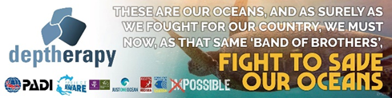

The data gathered is being analysed by Tom Oates and a report will be prepared. This was an excellent trail run for our 2022 major expedition to the Red Sea.

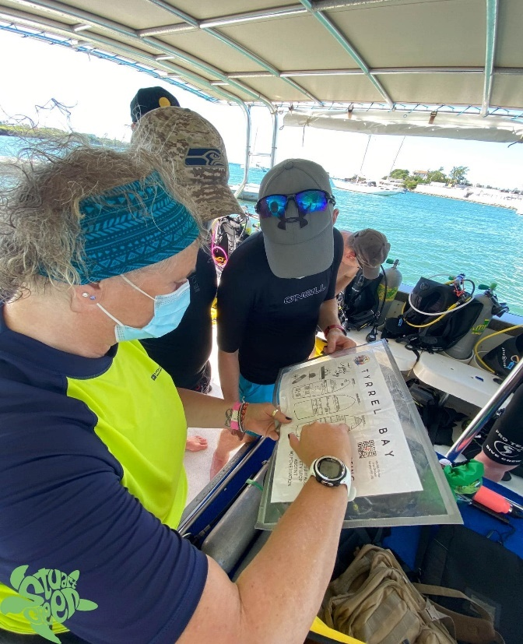
Dive Briefing - Sharon briefs Jason and Tom

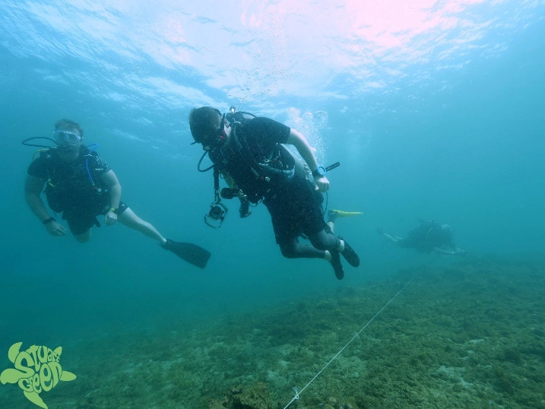
Corey shows that paraplegia is not a handicap to scuba diving

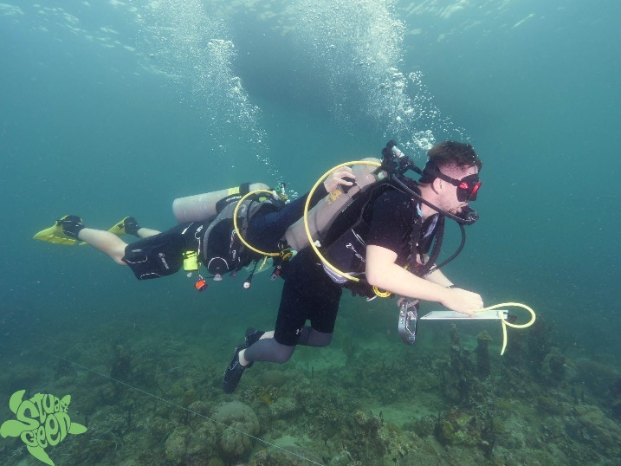
Corey supported by Tom collects data d=for the study

Safety is key to our work with beneficiaries, while learning and on courses they are closely supervised and supported. Scuba diving is regarded as an ‘extreme’ sport as you cannot breathe underwater with a cylinder of air and a set or regulators. Equipment, despite servicing and being kept in excellent condition does, albeit rarely fail. Scuba diving is about humans and sometimes humans make mistakes, This, is found more often in learning and novice divers than amongst experienced divers.

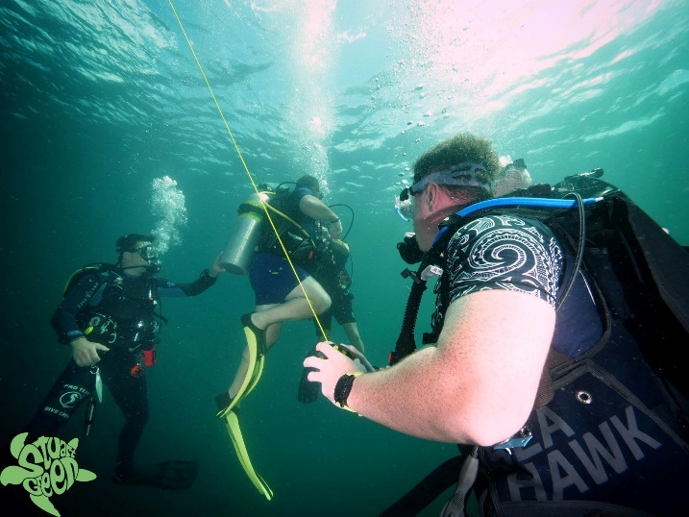
End of 35 metre wreck dive - at 5 metre safety stop –‘out of air’ Richard & Sean support the diver.

There was a great deal of media attention in Grenada about our visit and we featured on local television and radio.

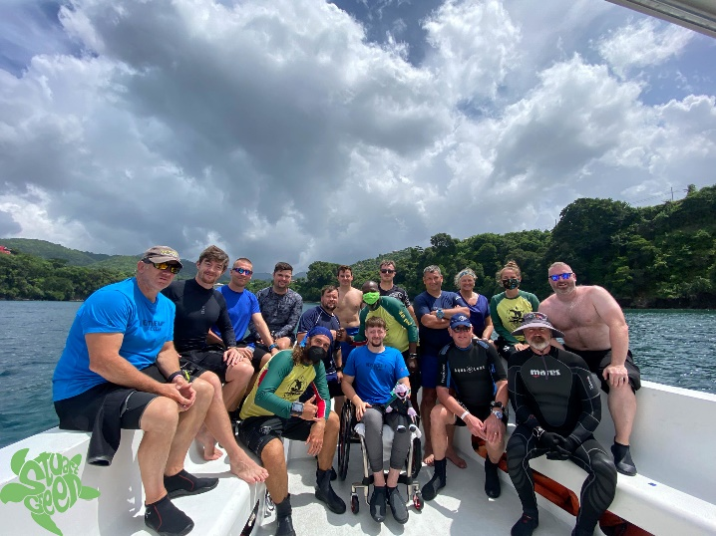
Smiling faces – beneficiaries and dive team

Sadly, our ten-day adventure came to an end all too quickly and we returned to the UK. We all have glowing memories of the Spice Island and the warmth of our welcome.

We left our stamp on the team at Aquanauts who wrote on social media:

“”Listening to each of their stories and hearing how Deptherapy has positively impacted their life, is powerful. Watching them work together as a team in and out of water, moves you.

Spend a few days working with Deptherapy and it will positively impact you too.”

Always remember we are volunteer led and run

Delivering three major programmes in three months; August, September and October would be an achievement for a charity that had a CEO and employed staff. Deptherapy does it without anyone being paid, with people giving up their own time, family time, work time to deliver for our beneficiaries.

The dive team gave 23 days of their time to deliver the three programmes and that doesn’t take into account all the planning and preparation.

It is easy to forget people like Stuart Green, who does all our photography work. Stuart spends hours processing photographs and making sure we have the right ‘shots’.

At home Jane who is our AD Press and Media combines looking after our publicity with her work and looking after a young family.

It is not just the expeditions! It is our 24/7 support; the Sheffield University Medical School research, the research programme itself; developing the bid to the Afghan project.

Preparing a bid to the Veterans’ Foundation to support our core courses next year. It is the accounts, the Board meetings and the general admin.

The rewards for all this are seeing our beneficiaries recover from their challenges and grow as individuals. The recognition from Government and elsewhere for the work of volunteer led and run charities is unfortunately negligible.

Press and Media

Jane secured excellent coverage for all three expeditions and for the AFCFT ‘Afghan grant’ A press release for the Veterans’ Foundation is planned for the new year.

The Way Forward, 2022 and beyond

This is what we intend to deliver:

“It didn’t bring back the old me (referring to Deptherapy) but helped me on the path to the new me”
Petra Walker 2021
Exploring Posttraumatic growth in British Veterans with PTSD

COVID has obviously not gone away and we need to be aware that whatever plans we make for 2022 may go, as they have in 2020 and 2021 go awry. We cannot though fail to plan and our plans for 2022 are well developed.

Hopefully our first event will be the GO Diving Show on 4th – 6th March at Stoneleigh, Warwickshire. We are scheduled to speak on the Main Stage at the event on all three days: 4th Trade and the two public days 5th – 6th. Our stand will be staffed by beneficiaries and volunteers.

The AFCFT Afghan Project will involve a considerable amount of work in the early months of 2022 as we tailor our offering to the needs of individual beneficiaries.

The programme will be delivered throughout the year.

We are supported in 2022 by grants from:

Our AFCFT project was originally due to commence in 2020, culminating in 2021. AFCFT have been very supportive of our response to COVID and allowed us to transfer the first part of our project to Grenada, as previously discussed.

COVID permitting Dr McNeill will run an intensive week of practical marine biology study at Roots from 23rd July to 31st July followed immediately by the one-week Red Sea liveaboard to conduct a bio mass study on the SS Thistlegorm and SS Turkia. The boat we will use for the week is Roots’ Big Blue.

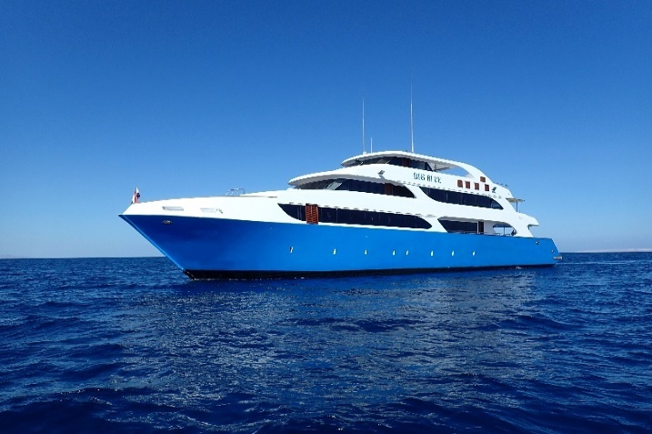

The boat was built to cater for those with accessibility needs and there are four fully accessible cabins.

We intend to run core courses from 23rd – 31st July at Roots, this will include RAID Open Water 20 courses and continuing education programmes.

Logistically we will, with the Marine biology programme running at the same time have circa 30 beneficiaries at Roots at the same time.

We will also look to run a further core course in October.

Scuba Diving is a dynamic sport

“Understand you don’t know everything; you have always got so much more to learn.”
Eddie Jones England RFU Team Coach/Manager

Unless you are a fool or have a massive ego then you never stop learning as a scuba diver, or like myself and most of the dive team when you have reached the pinnacle of diving profession.

Despite our combined experience in adaptive teaching the dive team has agreed to collaborate with an organisation called The Human Diver

www.humandiver.com

The organisation’s strap line is: Apply Human factors – Master the Dive

Amplifying the effectiveness of your diving skills and experience through specific human factors training

Human Diver’s Founder is Gareth Lock, who served in the RAF for 25 years. He is an experienced diver who saw the need to introduce human factors into diver training to ensure that dive teams are well led and risk is reduced for individual divers.

The dive team has already agreed to adopt the Human Diver’s debrief model and in the new year we will work with Gareth to establish how we collaborate and enter into a partnership.

“The underwater environment exposes divers to physical, physiological, and pathological stresses. No other industrial working environment alters normal worker physiology more than diving”
Blumenberg 1996

For the Deptherapy dive team this is another learning experience that will enhance our already risk averse core programmes and expeditions.

Veterans Protecting Our Oceans

There is a huge appetite among our beneficiaries for protecting the oceans. Enthusiasm and interest have grown exponentially in recent years and provides a focus for many of our beneficiaries. It provides to many a real sense of giving back. Giving back for what our seas have given them.

The 2022 Red Sea Bio Mass study with our group of beneficiaries who are now citizen scientists is much anticipated by the team.

We have asked Tom Oates and Jason Court to look at locations for our 2023 Expedition we could contribute to local knowledge about their underwater eco-systems and the Board will consider their proposals in the new year.

A MAJOR ANNOUNCEMENT

On Wednesday 5th January RAID, our diver training agency partner, issued a Press release announcing that Deptherapy Chair and Head of Operations Richard Cullen has been appointed as Director of Adaptive Teaching.

This is an unpaid position on the RAID Board and has global responsibility. I am humbled to be invited to take this major post within the RAID organisation.

The Press Release:

“Richard Cullen appointed to RAID board
Deptherapy Founder joins as Director Adaptive Training

Dive RAID International announced today that there will be a special focus on their adaptive training program as Richard Cullen joins the agency’s staff.

Cullen, well-known as one of the founders of Deptherapy has been appointed Director Adaptive Training and joins the agency immediately. Deptherapy develops and delivers specially designed SCUBA diving programs for seriously injured veterans and serving personnel of the British Armed Forces. The Deptherapy program has helped many hundreds of men and women deal with post-trauma mental and physical challenges following all manner of injuries suffered while serving in the military.

In his new role as RAID’s Director Adaptive Training, Cullen will take over product-development responsibilities for the RAID Adaptive Diver program. Working with RAID’s VP Training, PJ Prinsloo, Cullen will be rewriting both student manuals, creating new instructor materials in-line with RAID’s instructor playbook format. Cullen will also work on related support materials, and new standards promoting what he called a neglected but highly rewarding aspect of diver training.

Cullen said: “I am honoured and humbled to become RAID’s Director Adaptive Teaching. I hope to bring to RAID the knowledge and experience we have gained over the years in Deptherapy developing an innovative approach to adaptive teaching. My aim is to make RAID the go-to diver training agency for knowledge and advice regarding adaptive teaching.”

He went on to explain that adaptive teaching in most diver training agency has been stagnant for many years and the changes he plans will benefit the community with the development and innovation a major agency brings to the ‘poolside.’

“Our new approach at RAID, will make scuba diving accessible to those within our communities who have mental and physical challenges.” He said.

We are excited about Richard joining our training team because he brings to RAID a wealth of knowledge developing teaching strategies and hands-on experience working with people with all manner of different challenges (both physical and mental). That deep knowledge gained from years with Deptherapy will be invaluable for RAID Dive Centres and instructors who are interested in working with and offering scuba instruction at all levels to divers of all abilities.”

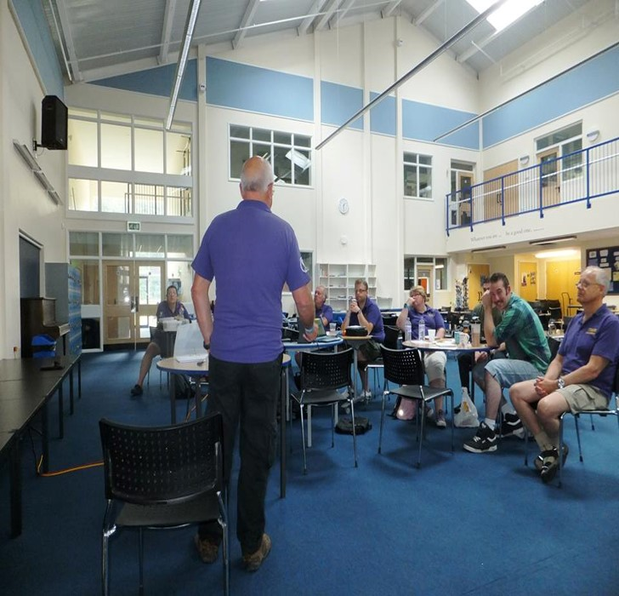
A Deptherapy Education Instructor’s Course being run at Divecrew

SOME PERSONAL REFLECTIONS:

- Firstly, I see this as an absolute endorsement of how the Deptherapy Team has developed ‘adaptive teaching’. It is a vote of confidence in the team and not just me.
- This will not affect my input to Deptherapy
- Courses etc will be dual branded as RAID/Deptherapy
- This is about Adaptive Teaching and not the Deptherapy programme. There is a distinct line between the all encompassing Deptherapy Programme that extends beyond adaptive teaching.
- Adaptive teaching has been stagnant for a number of years, within Deptherapy we have moved this forward.
- Understanding mental health and how it coalesces with adaptive teaching is a major part of a new approach to teaching those with mental and, or physical challenges to dive.

We discussed earlier the medical/academic studies that Deptherapy has commissioned and will commission in the future. Unfortunately, many of the dive industry have picked up the mantra that scuba diving is good for mental health and encouraging those with depression, anxiety etc to dive.

Such processes need to be managed and staff involved in such training need to be mental health aware and certainly should have completed more than a 2-day adaptive teaching course.

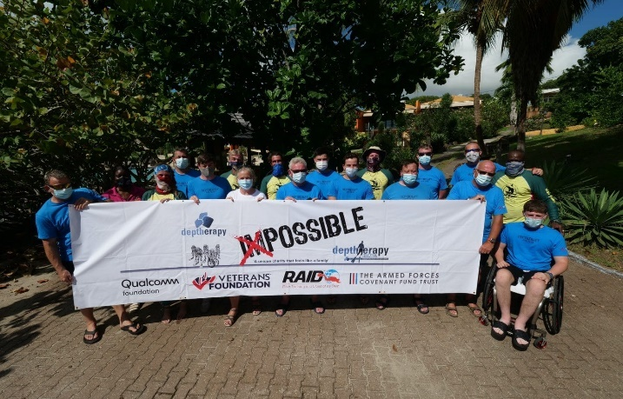
Deptherapy in Grenada

Happy New Year 2022 to you all. Thank you for supporting our beneficiaries, in whatever way and whatever role, throughout 2021

TEAM DEPTHERAPY

Trustees:

Chair and Head of Ops
Richard Cullen,

Board Secretary and Solicitor
Sarah Waddington

Finance
George Bell

Programme Member Liaison
Michael Hawley

Martin Weddell

Associate Directors:

Press and Media
Jane Herbert

IT and Data Protection
Simon Mackay

Dive Medicine Advisor
Dr Mark Downs

Programme Support
Sharon ElShoura

President
Debra Lilley

Vice Presidents
Dr Richard Castle
Paul Rose

Mental Health Champions
Tom Oates
Danny Martin

Instructional Team
Richard Cullen
Martin Weddell
Sharon ElShoura
Steve Rattle
Carl & Michelle Tears
Andy Frith
Sean Martin
Chris Middleton
Michael Hawley
Jonathan Beever
Stuart Green (Photographer)

2021 was yet again a year of achievement as we hope will be 2022 and beyond.

Dr Richard Cullen; Ost.J, FRGS, MA
Chair
Deptherapy & Deptherapy Education
Charity Commission No. 1166310

