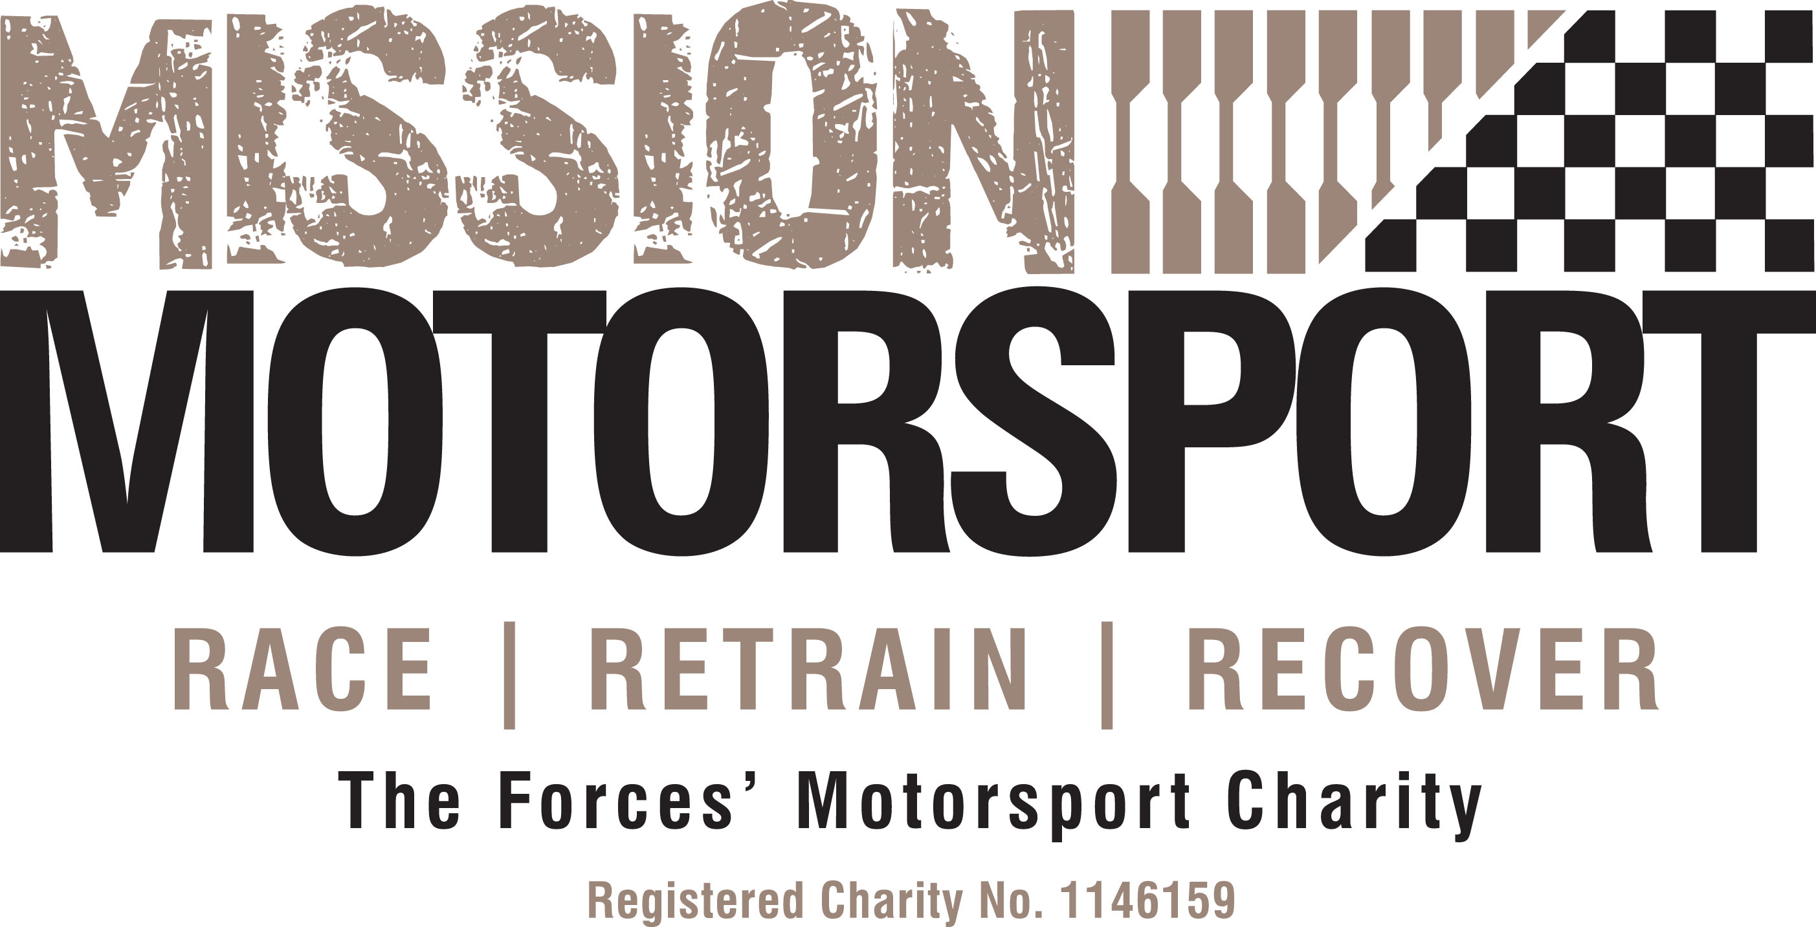
JOB SUMMARY AND PERSON SPECIFICATION

Job Title: Executive and Communications Assistant

Reports to: CEO

Based at: Working from Home, Working from CEO’s external Office & MMHQ Wantage – OX12 9TF

Job Purpose | The Executive and Communications Assistant works directly with the CEO and the Mission Motorsport and Mission Community executive team, to manage outer office functions, commitments and resources across the Mission Group of charities.  This is a pivotal role in ensuring the smooth operation of the CEO's office whilst also assisting in the development and implementation of the Charity's communication strategy. It will require a proactive, detail-oriented, and adaptable professional who can skilfully balance administrative responsibilities while also contributing to the development and implementation of the charity's communication strategy. The post works directly with the CEO in order to support his work, and that of the Mission Group Exec Team, to manage diaries and complete any administrative tasks as necessary.

Main Responsibilities | Executive Assistant Responsibilities:  - Maintain the CEO's calendar, schedule appointments, and coordinate meetings with a strategic focus on optimising the CEO’s time for high-priority tasks and initiatives.  - Serve as a primary point of contact for internal and external communications on behalf of the CEO through appropriate channels, and ensure a seamless flow of information internally within Mission Group and externally.  - Draft and edit emails, memos, reports, and other documents as needed.  - Prepare meeting materials, agendas, and take minutes when required, including preparing for trustee meetings and support to the Company Secretary with agendas, papers and minutes.  - Manage and prioritize tasks to ensure the CEO's time is utilised efficiently.  - Provide critical decision support by conducting thorough research, preparing briefing materials, and offering insights on key issues.  - Handle travel logistics, including booking flights, train tickets, accommodation, and preparing itineraries.  - Handle sensitive and confidential information with the utmost discretion and professionalism.  - Prioritise tasks and coordinate projects to align with the CEO's goals and objectives.  Communications and Marketing Responsibilities:  - Collaborate on the creation of engaging content for various communication channels, maintaining a consistent and impactful organizational voice.  - Monitor and curate content for the Mission Community’s corporate media platforms, ensuring alignment with strategic communication goals. Cultivate and maintain positive relationships with media outlets and respond to media inquiries, elevating the charity's profile.  - Play a key role in planning and executing MC events, including conferences and outreach programs.  - Ensure a cohesive and powerful organisational brand across all communication materials and platforms.
Essential Knowledge, Skills & Experience | - Motivated self-starter with a commitment to beneficiary care and the ability to work co-operatively within an integrated small team dedicated to achieving successful outcomes for beneficiaries.  - Proven experience as an executive or administrative assistant, with a track record of providing high-level support, minute/ note taking and report writing.  - Strong organisational and communication skills with the ability to draft clear and compelling content.  - Knowledge and understanding of project management processes.  - Experience in stakeholder management across a broad range of stakeholders and audiences.  - Familiarity with social media platforms and content creation.  - Exceptional organisational and multitasking abilities.  - Proficiency in Microsoft Office Suite and other relevant tools.
Desirable Knowledge, Skills & Experience | - A knowledge of Salesforce CRM or similar  - A knowledge of GDPR  - A knowledge of the military (serving or veteran, relative or own prior service)
Key Competencies & Behaviours | - Demonstrates the ability to build a rapport quickly and to understand needs, wants and expectations.  - Displays a positive, empathetic, patient, polite and friendly manner.  - Manages challenging situations in a calm and appropriate manner.  - Ability to remain calm under pressure.  - Displays the highest levels of integrity, confidentiality and commitment.  - Responds quickly to changing demands and demonstrates strong skills in prioritisation and time management.  - Able to work within a range of environments and working cultures, adapting personal style accordingly.  - Able to analyse information quickly and communicate in a concise and articulate manner.  - Demonstrates attention to detail in all aspects of work.  - Ability to work as part of a team and be a flexible team player.  - Flexible re. hours of work.  - Prepared to travel and attend weekend events away from home at various motorsport locations throughout the UK.
T&Cs | - Full time contract  - Workplace Pension Scheme  - Flexible working between Wantage and Newbury

