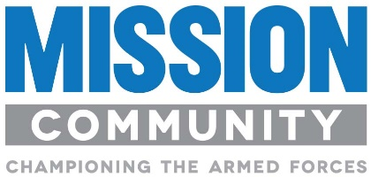
JOB DESCRIPTION

Job Title: MISSION COMMUNITY PROJECT SUPPORT OFFICER

Based at: Hybrid Working (Home based)

Reporting to: Chief of Staff, Mission Community

The Role

To provide a comprehensive support function to the Mission Community (MC) Team, working across the Mission Community’s portfolio of projects, providing support to the existing Sector initiatives, and to the development of new ones, delivered under the Armed Forces Covenant Fund Trust (AFCFT) grant. The role is diverse, but integral to the success of Mission Community in delivering successful outcomes for the Armed Forces Community. The role is multifaceted and multifunctional in the provision of project and administrative support to MC in general and the Armed Forces Engagement Leads in particular. The role requires excellent communication and organisational skills and will involve liaising at all levels internally as well as working externally with key stakeholders.

Key Responsibilities and Tasks | - Provide project support to the MC Team and MC Events including National Transition Event (NTE), including correspondence, record maintenance, data entry and reporting, invoicing and other administrative tasks.  - Assist in the production and coordination of AFCFT project internal and external reporting requirements, including impact measurements and KPIs.  - Support and help coordinate the development of Sector Initiative planning, toolkit development and project risk and issues management.  - Develop and support the delivery of both internal and external communications allied to the project, including the creation of and regular posting on Social Media Channels – Twitter, Facebook, LinkedIn and Instagram etc.  - Assist the MC Chief of Staff in the management of MC processes and procedures to ensure optimal efficiency and productivity of MC resources.  - Assist in the day-to-day monitoring of the financial management, planning and reporting of AFCFT grant funding, as set out by the AFCFT against defined KPIs and other metrics that support agreed outcomes.
Essential Knowledge & Experience | - Proficient with Outlook, Word, PowerPoint and Excel (ECDL Qualification or equivalent).  - Good knowledge of all MS Office applications (including SharePoint) plus project support tools such as MS Project.  - Experience in previous project support/project administration role.  - Excellent interpersonal and communication skills.  - Ability to work on own initiative.  - Ability to prioritise workload.
Desirable Knowledge & Experience | - A good understanding of Armed Forces personnel, veterans and spouses, and their employability.  - Communications/Marketing experience, ideally in the charity sector.  - Experience in dealing with press/media.
Key Competencies & Behaviours | - Strong management, communications and interpersonal skills.  - Motivated self-starter with the ability to work co-operatively as part of a geographically distributed team within a dynamic rapidly developing environment.
Ts & Cs | - Full-time  - Permanent  - Workplace pension scheme  - 25 days holiday + bank holidays  - Hybrid working with some UK travel and occasional weekend work

