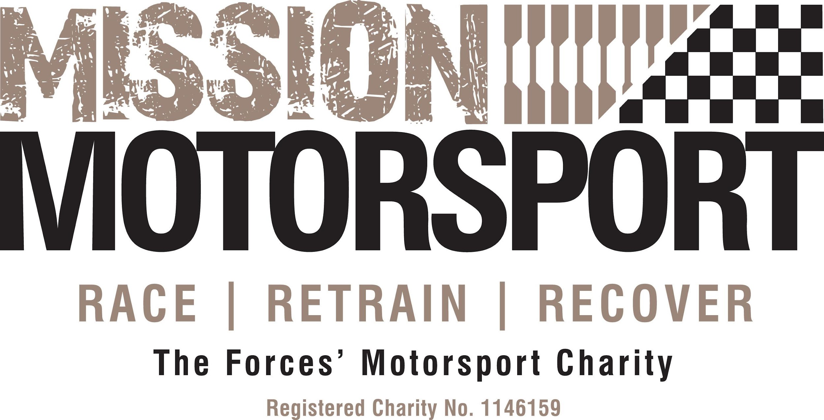
JOB SUMMARY AND PERSON SPECIFICATION

Job Title: Head of Donations, Grants & Sponsorship

Reports to: Mission Motorsport Managing Director, Group CEO

Line Manages: Community Fundraiser (TBC)

Based at: Hybrid

Job Purpose | The Head of Donations, Grants & Sponsorship (DGS) works closely with the Exec Team to develop and deliver the charity’s income generation strategy in support of current and future plans. The role is responsible for building a sustainable income platform, and managing the charity’s fundraising activities including environmental issues, social issues, and corporate governance. This includes developing innovative income generating approaches, engaging supporters, and shaping future fundraising efforts as the charity grows and develops. The output of this role will be the creation and management of sustainable funding streams to support the existing plans and ambitions for growth.

Main Responsibilities | Strategy development and delivery  - Prepare and deliver a long-term income generating strategy and comprehensive annual plans, covering all income streams (less commercial trading), including but not limited to trusts, philanthropy, corporate and individual giving, grants, sponsorship, and legacies.  - Plan and deliver activity that ensures annual income targets are met.  - Co-ordinate and manage income generation activity, including community, trust, corporate, major/ HNW donor and digital fundraising across the charity.  - Work closely with others to ensure that fundraising is integrated effectively with other areas of the Charity’s work, and that there is effective synergy between fundraising and other outputs.  - Maintain an up-to-date knowledge of the law and governance surrounding fundraising and communications activities and ensure that any fundraising activity complies with relevant legislation at all times, including contract compliance, GDPR, Fundraising Regulator and Insurance requirements.  Donors/ Grants/ Sponsors  - Be responsible for the stewardship of all key supporters and donors, as agreed with the Exec team and incompliance with GDPR regulations including:  - regular communication and engagement.  - developing a donor recognition policy and programme, and donor engagement events.  - Developing and managing high-profile partnerships, including trusts, corporate and major supporters  - Manage and improve systems and processes for record keeping and reporting on sponsor/ donor relationships (within an appropriate CRM system).  - Act as an ambassador for the Charity at meetings and events, with partners, donors and prospective donors.  - Build relationships with charitable trusts, foundations and other institutional funders maintaining long-term fundraising relationships.  Innovation  - Create compelling, emotionally powerful funding propositions with appropriate budgets, and agreed targets and costings, to support strategic/capital projects as outlined in the strategic plan.  - Identify and develop new funding streams from trusts and foundations to support the work of Mission Motorsport.  - Conduct detailed, on-going research into new funding opportunities and prospective supporters.  Monitoring, Marketing and Reporting  - Monitor, report on progress against the fundraising plans and agreed KPIs, and grants, including but not exclusively VPPP, ABF, and Barclays.  - Prepare and present reports and updates to the Exec and Board as required on all fundraising and income generating activity.  - Work closely with Head of Comms/ Marketing to develop and deliver successful fundraising campaigns, marketing and engagement activity through appropriate channels and platforms.  - Assist with and support the organisation of events and activities when required/ as appropriate.
Essential Knowledge, Qualifications & Experience | - Knowledge and experience of multiple fundraising channels, including major donor, corporate and community fundraising.  - Excellent written and oral presentation skills, with the ability to communicate the mission, purpose and impact of Mission Motorsport.  - Excellent interpersonal and relationship building skills, to represent the Charity and persuade potential donors to support its cause.  - Experienced in the use of a CRM system to record and plan activity.  - Familiar with Institute of Fundraising codes of practice and data protection legislation.  - Fluent in Microsoft Office programs and database software.
Desirable Knowledge, Qualifications & Experience | - A knowledge of CRM systems, dashboards and reporting  - Experience and understanding of the armed forces community.  - An interest in motorsport.  - Digital media marketing and innovation experience.
Key Competencies & Behaviours | - Displays a positive, empathetic, patient, polite and friendly manner.  - Manages challenging situations in a calm and appropriate manner.  - Ability to remain calm under pressure and work effectively with limited resources.  - Displays the highest levels of integrity, confidentiality and commitment.  - Responds quickly to changing demands and demonstrates strong skills in prioritisation and time management.  - Able to work within a range of environments and working cultures, adapting personal style accordingly.  - Able to analyse information quickly and communicate in a concise and articulate manner.  - Ability to work to deadlines, and under pressure, managing several projects at a time.  - Ability to work as part of a team and be a flexible team player.  - Flexible re. hours of work and prepared to travel and attend events away from home/ at weekends as required.
T&Cs | - Full time contract  - Workplace Pension Scheme  - Hybrid working

