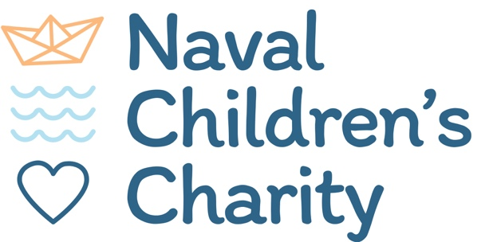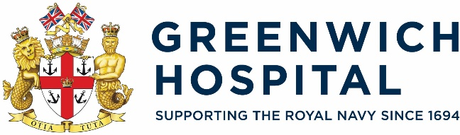

Candidate recruitment pack
Join us in improving the wellbeing and development of our Naval children and young people.

Our Vacancies:
Triage Caseworker (Education)

Foreword
Dear Candidate,
I would like to thank you for considering applying for one of our exciting vacancies at the Naval Children’s Charity. Hopefully this Candidate Recruitment Pack will be helpful in supporting you to find out more about us as an organisation, and potential new employer. It includes some encouragement to get in touch and have a conversation with us if you are thinking about applying, and details on the application and recruitment process itself. We would love to hear from you, please give us the opportunity to showcase to you why we could be a great next step in your career.
This is a great time to join the Naval Children’s Charity. We have changed and grown significantly over the past few years, despite the challenges of the pandemic and other global stressors. We have redefined our Mission and Vision and our Team have worked hard to develop our work culture and how we can best support our children and young people.
Part of our new strategy is to put the voice of the Naval child/young person at the heart of what we do. Our new Youth Council are really helping us develop our support offer and ensure that we are hearing and meeting their needs.
We aim to provide a consistent, fair and inclusive application process which is why we ask you to fill out an application form. We do want to get to know you as a person as part of this process so please tell us as much as possible about yourself.
We are currently a Bronze Award member of the Armed Forces Covenant’s Employer Recognition Scheme. We are Armed Forces friendly and welcome applications from reservists, veterans, military spouses and partners.
We look forward to hearing from you.


Clare Scherer MBE
CEO, Naval Children’s Charity

About us

The Naval Children’s Charity (NCC) are dedicated to improving the wellbeing and development of Naval children
and young people.

We provide a wealth of support, guidance and resources to help dependant children (up to and including the age of 25) whose parents/guardians serve or have served in the Royal Navy and who are in need, hardship or distress. With a team of caseworkers in Portsmouth, Helensburgh and Plymouth, we offer financial assistance, free resources and a range of opportunities to address the challenges that children and young people face as a result of their parents’ service.
2025 saw us celebrating our Bicentenary. 200 years since the first orphanage was opened in Portsmouth. We are so proud of our rich heritage and working together to ensure we continue to evolve and respond to the challenges that our children and young people face.
We have a long history of Royal Patronage and deeply proud that this continues with HRH The Princess Royal picking up this role in 2025.




Our mission
To support the wellbeing and development
of children and young people from Royal Navy and Royal Marines families, serving and veteran, in recognition of the unique situations they and their families face.
Our vision
That every Royal Navy and Royal Marines child and young person has their spirit and talent unlocked, giving them a brighter future and helping them to realise their full potential.

Our values
- Collaborative
- Trusted
- Empathetic
- Children and young people at the heart of what we do.

What we do

Wellbeing and development support for children and young people.






Support for Parents/Carers
Advice and guidance
Support and opportunities for children/young people
Mental health



Bereavement Family breakdown Disability, illness or
injury
Neurodiversity / SEND
/ ALN



Financial / debt
Advice and guidance
Education Wellbeing Packs

Vacancies
Job Title – Triage Caseworker (Education)
Salary: £16,571 (20 hours per week FTE £29,000)
30 days annual leave (FTE),
7.5% matched pension contribution
Part time (20 hours per week), short term contract from April 2026 – September 2027. This is an 18 month pilot with a potential for continuation.
Location: Remote working
Line manager: Senior Triage Caseworker

Job Description
The role is 20 hours per week, negotiable, working remotely but with frequent visits to the NCC
Head Office in Portsmouth for training and assimilation into the Caseworking team.

Working as part of the NCC Casework Team, the Triage Caseworker (Education) will be the first point of contact for beneficiaries seeking educational support through the Greenwich Hospital Go Learn - Free online tutoring for Naval families and the NCC University Bursary Programme. This role involves following the triage processes to assess the needs of the children to provide recommendations for tutoring/bursary support. Assessments may lead to referrals being made to the NCC for financial assistance for other child/family needs, advice, and support in the management of finances, and child specific needs

Key Tasks and Responsibilities
Caseworkers provide support and advice to eligible individuals in line with the policies of the Naval Children’s Charity. They work closely with other organisations to ensure that children and families receive appropriate and prompt support.
The role of Triage Caseworker (Education) is to assess the eligibility for support through the Greenwich Hospital Go Learn and The NCC University Bursary Programmes. Where additional child and family needs are identified, recommendations for appropriate assistance to the NCC Casework Team will be required. Caseworkers should be empathetic and non-judgmental.
Caseworkers will receive induction training in the NCC’s Beacon database, Microsoft forms and other tools necessary to the role. The role is subject to DBS checking.

Go Learn - Free online tutoring for Naval families
- To act as the first point of contact for enquiries and applications from beneficiaries, providing a calm, supportive and professional welcome
- To complete an initial assessment of eligibility and, where necessary, further assessment through telephone calls and emails
- To use active listening and empathetic communication to build trust and ensure beneficiaries feel heard
- Provide appropriate information to the Go Learn providers to enable the family to receive appropriate support.
- Accurately record beneficiary information into Beacon, ensuring timely, detailed, and confidential case notes
- Log and track applications and progress of tutoring delivery
- Assess and evaluate outcomes from tutoring
- If necessary, refer the family to the NCC Triage team for additional support.
- Provide clear information about available support, signposting, or referrals
- Follow up with beneficiaries once support has been completed to ascertain impact

University Bursary Programme:
- To act as the first point of contact for enquiries and applications from beneficiaries, providing a calm, supportive and professional welcome
- To complete an initial assessment of eligibility and, where necessary, further assessment through telephone calls and emails
- To use active listening and empathetic communication to build trust and ensure beneficiaries feel heard
- Provide appropriate information to the Aspire platform to enable the young person to receive the support
- Accurately record beneficiary information into Beacon, ensuring timely, detailed, and confidential case notes
- Log and track applications and progress of bursary delivery.
- Assess and evaluate outcomes from bursary.
- If necessary, refer the young person to the NCC Triage team for additional support.
- Provide clear information about available support, signposting, or referrals
- Follow up with beneficiaries once support has been completed to ascertain impact

General duties:
- Ensure confidential handling of all information concerning beneficiaries in accordance with The Naval Children’s Charity’s confidentiality and data protection policies
- Keep thorough, confidential and systematic records of all matters concerning enquiries, applications, and grant awards in accordance with The Naval Children’s Charity’s data protection policies
- Regularly update personal training and skills
- Such other relevant duties as may be assigned from time to time

Essential | - Professional background in education with an understanding of additional needs  - Be able to demonstrate empathy, emotional intelligence, and non-judgmental communication  - Evidenced knowledge and experience of charitable and financial support to beneficiary groups  - Strong communication, organisational and record keeping skills  - Ability to work unsupervised
Desirable | - Confident using IT including Microsoft Office; knowledge of grants or other CRM  - Experience of recording information into a CRM (training will be provided)  - Evidence of working effectively in co-operation with other charities and organisations  - Understanding of military life and the impact on serving personnel, veterans and their families  - Familiarity with the Royal Navy and the Service charity sector
Personal qualities | - Adherence to NCC’s values  - Integrity, honesty and professionalism at all times  - Able to treat all people with respect and dignity  - Willing to take responsibility for actions and remain accountable  - A team player

The tasks listed in this job description are not designed to be exhaustive and may vary from time to time according to the needs of the Charity. This document will be reviewed in consultation with the post holder as the role and services provided by the organisation develop.
The Naval Children’s Charity is committed to safeguarding and promoting the welfare of children, young people and vulnerable adults and expects all staff and associated professionals to share this commitment.
Next steps
To apply, please complete the application form on our website and submit it alongside a letter/personal statement setting out the values, skills and experience that you have that makes you suitable for this role to Sara Smith, Head of Operations, by the deadline indicated below.
We hope that this candidate recruitment pack has piqued your interest in joining us and we would actively encourage you to have a pre-application chat if you would like to do so. To arrange please contact Sara Smith, Head of Operations at sara.smith@navalchildrenscharity.org.uk

Deadline for applications | 27th February
In-person interview (In Portsmouth) | 10th March

Applications will be assessed as they are submitted on a rolling basis so early application is encouraged.

We are committed to finding the best fit for our team and creating a fair, objective recruitment process. Therefore, as part of our selection process, shortlisted candidates will be asked to complete the following assessments provided by Thomas International:
- Personal Profile Analysis (PPA)

- Trait Emotional Intelligence (TEIQue)
- High Potential Trait Indicator (HPTI)

To find out more please visit:
https://www.thomas.co/assessments/psychometric-assessment-aptitude-tests

The Naval Children’s Charity aims to provide help and support for children and young people who, through personal circumstances, are in need, hardship or distress. Our Vision is to be ready in a changing future to ensure that every deserving and eligible child has information and access to support from the Naval Charity Sector – because a society that has children at its heart is a better society for everyone.

Naval Children’s Charity
311 Twyford Avenue, Portsmouth, United Kingdom
www.navalchildrenscharity.org.uk 02392 639534
Registered CIO: The Naval Children’s Charity 1160182 and SC052322 in Scotland.

